Machine Learning Quarter 1 Project: Vehicle Damage Model

Ryan Ghimire and Aniketh Luchmapurkar

Thomas Jefferson High School for Science and Technology

Machine Learning 1

Dr. Yilmaz

September 22, 2024

# Table of Contents

**Part 1: Project Statement** (Page 3)

**Part 2: Dataset Description** (Page 3-11)

**Part 3: Preprocessing** (Page 11-12)

**Part 4: Attribute Selection** (Page 12-15)

**Part 5: Training and Analysis** (Page 16-40)

**Part 6: Conclusion and Tasks Performed** (Page 40-41)

**Part 7: Reproducibility of Best Model** (Page 42-44)

**References** (Page 44)

# Machine Learning Quarter 1 Project: Vehicle Damage Model

# Part 1: Project Statement

This project aims to utilize the Automated Crash Reporting System of the Maryland State Police to create a model that predicts the extent of damage caused by a traffic collision. The model aims to analyze various factors contributing to the damage of a vehicle after an accident. Specifically, we aim for the model to be able to classify the type of damage the vehicle involved in the collision sustained (Superficial, Functional, Disabling, Destroyed, and No Damage). As there are more than two possible outputs possible, this would be considered a multi-classification problem. In a real-world scenario, emergency services could use our model to predict the severity of vehicle damage before arriving at the scene of a traffic collision, allowing for them to prioritize more critical accidents. Along with this, our model could locate intersections or roads that are more prone to accidents, prompting authorities to implement better road designs, more traffic signals, or speed regulations at those locations.

**Part 2: Dataset Description**

The Montgomery County Police Department compiled a dataset of car accidents, with each instance being one accident. We are using the CSV format version of the dataset (it is called “Crash Reporting - Drivers Data”). A link to the dataset is present in the references section. There are 184,898 instances, 38 features (hence 38 dimensions), and one class attribute.

The first three features are for logistical purposes and keeping track of each separate incident (ASRC report number, local agency report number, and investigating local agency). The other features that come later are useful for a multi-classification problem, which we are doing. Most of these features are considered categorical data (with the key exceptions being IDs, report or case numbers, latitude, longitude, and location). We chose the “Vehicle Damage Extent” to be our class attribute as it best corresponds to our research goal of analyzing damage caused by a traffic collision. The possible values of this attribute which we are to classify with our model are - as aforementioned - Superficial, Functional, Disabling, Destroyed, and No Damage. The full list of features and the class are as follows:

1. Report Number
   1. Automated Crash Report System (ACRS) report number of incident
2. Local Case Number
   1. Local investigating agency case number for incident
3. Agency Name
   1. Local investigating agency name
4. ACRS Report Type
   1. Classifies crash as property, injury, or fatal
5. Crash Date/Time
   1. Date and time of crash
6. Route Type
   1. Crash location’s roadway type
7. Road Name
   1. Crash location’s road name
8. Cross-Street Name
   1. Name of nearest street to crash location
9. Off-Road Description
   1. Description of location for off-road collisions
10. Municipality
    1. Crash location’s jurisdiction
11. Related Non-Motorist
    1. Types of (if any) non motorists involved
12. Weather
    1. Weather at crash location
13. Surface Condition
    1. Roadway condition at crash location
14. Light
    1. Lighting conditions at crash location
15. Traffic Control
    1. Traffic control devices (ex: stop sign or traffic light) at crash location
16. Driver Substance Abuse
    1. Whether driver abusing substances
17. Non-Motorist Substance Abuse
    1. Whether bystander of collision abusing substances
18. Person ID
    1. Reporting party’s ID
19. Driver At Fault
    1. Whether driver at fault for collision
20. Injury Severity
    1. Severity of injury to driver
21. Circumstance
    1. Special circumstances for this collision
22. Driver Distracted By
    1. Reason for distracted driving
23. Drivers License State
    1. State that issued driver’s license
24. Vehicle ID
    1. Crashed vehicle license plate
25. Vehicle Damage Extent
    1. Severity of damage to vehicle
    2. **Class attribute**
26. Vehicle First Impact Location
    1. Location of first impact on vehicle
27. Vehicle Body Type
    1. Whether passenger car, SUV, truck, etc
28. Vehicle Movement
    1. Whether parked, reversing, driving forward, turning, etc.
29. Vehicle Going Dir
    1. Cardinal direction of vehicle movement before collision
30. Speed Limit
    1. Posted speed limit of roadway at collision
31. Driverless Vehicle
    1. Whether vehicle autonomous/driverless or not
32. Parked Vehicle
    1. Whether vehicle parked before collision
33. Vehicle Year
    1. Model year of vehicle (ex: 2024)
34. Vehicle Make
    1. Brand/make of vehicle (ex: Toyota)
35. Vehicle Model
    1. Model of vehicle (ex: Corolla)
36. Latitude
    1. Latitude of accident
37. Longitude
    1. Longitude of accident
38. Location
    1. (Latitude, Longitude) of accident

**Figure 1**

*Histogram of output frequencies*

*Note.* Histogram depicting frequency of each class output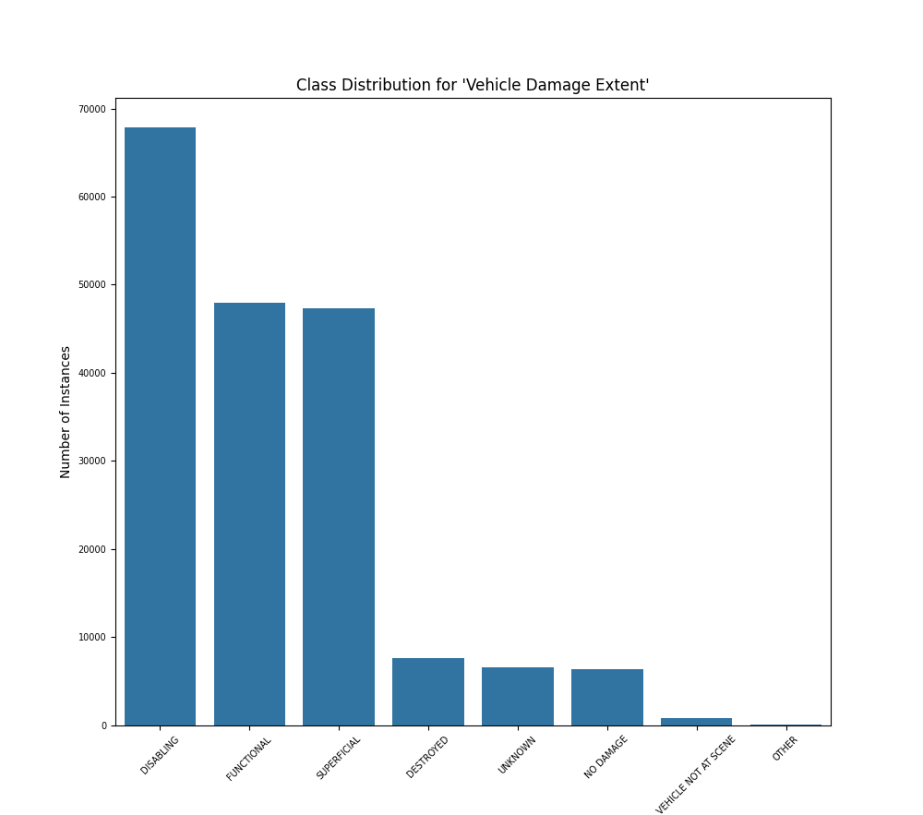

As seen in Figure 1 above, the class distribution is significantly skewed, with the majority of crashes disabling the vehicle. The data has a skewness of 0.826. This is likely due to the fact that most traffic collisions where law enforcement is called are major enough to disable the vehicle; very minor accidents would not require having to call law enforcement in the first place. The specific frequencies of each output are below in Table 1.

**Table 1**

*Table of output frequencies*

| Class Output | Frequency |
| --- | --- |
| DISABLING | 67,822 |
| FUNCTIONAL | 47,906 |
| SUPERFICIAL | 47,297 |
| DESTROYED | 7,610 |
| UNKNOWN | 6,620 |
| NO DAMAGE | 6,378 |
| VEHICLE NOT AT SCENE | 846 |
| OTHER | 102 |
| Blank/Missing | 316 |

*Note.* Frequency of occurrences of each class output

As seen in Table 1 above, the class attribute has 316 blank values as well as 6620 values labeled as “UNKNOWN,” 846 labeled as “VEHICLE NOT AT SCENE,” and 102 labeled as “OTHER;” all of these values are considered missing values and have to be dealt with when preprocessing the data. Shown in Table 2, 35 out of the 37 other attributes also have missing values and will have to be dealt with the same way as the missing values in the class attribute.

**Table 2**

*Table of missing values*

| Attribute | Number of Missing Values |
| --- | --- |
| Report Number | 184897 |
| Local Case Number | 184829 |
| Agency Name | 0 |
| ACRS Report Type | 0 |
| Crash Date/Time | 184897 |
| Route Type | 18161 |
| Road Name | 19364 |
| Cross-Street Name | 28452 |
| Off-Road Description | 178336 |
| Municipality | 165771 |
| Related Non-Motorist | 179002 |
| Collision Type | 1388 |
| Weather | 14133 |
| Surface Condition | 21848 |
| Light | 3826 |
| Traffic Control | 26879 |
| Driver Substance Abuse | 44756 |
| Non-Motorist Substance Abuse | 180420 |
| Person ID | 158038 |
| Driver At Fault | 4686 |
| Injury Severity | 789 |
| Circumstance | 165594 |
| Driver Distracted By | 36683 |
| Drivers License State | 11432 |
| Vehicle ID | 158050 |
| Vehicle First Impact Location | 3238 |
| Vehicle Body Type | 9139 |
| Vehicle Movement | 4133 |
| Vehicle Going Dir | 10108 |
| Speed Limit | 76171 |
| Driverless Vehicle | 741 |
| Parked Vehicle | 1534 |
| Vehicle Year | 176514 |
| Vehicle Make | 4222 |
| Vehicle Model | 16884 |
| Latitude | 126026 |
| Longitude | 111757 |
| Location | 158834 |

*Note.* Number of missing for each attribute

**Part 3: Preprocessing**

Firstly, we realized that our dataset had some formatting issues so we created a Python script (“cleaner.py”) to get rid of newline characters and “\” characters. This script, along with all others mentioned in this document, are located in the Google Drive folder for reference.

Attributes related to IDs and investigating agencies have no importance in classifying damage to vehicles. As such, we would get rid of these attributes entirely (in other words, we would delete that “column”). Furthermore, we delete the location attribute as it is derivable from latitude and longitude.

We also realized that a model trained on the crash date/time would not be able to gain much relevant, unique information from said attribute; all of the impactful information it could gain (i.e. time of day) is already accounted for in other attributes (i.e. light). In other words, it is yet another derivable attribute that can be removed.

Additionally, we would need to get rid of the instances with blank or missing attributes. We would also need to get rid of instances with outputs that are blank, Other, Unknown, or Vehicle not at Scene. These last three deletion steps were done by use of the “base_preprocessing.py” Python script.

Along with this, the “NO DAMAGE” label had extra quotes around it which we had to get rid of so it matched the other attributes, which we did using the fixNoDamage.py.

As most, if not all, of the data in our dataset is categorical, we would need to change them to numeric/quantitative forms. Most are True/False type data, meaning it can be easily changed to 1 and 0, respectively. The others which have several options will have to be converted to a 0-[number of options available] scale. This was done using the “encoder.py” script.

All these different scales (0-1 and 0-[number of options available]) would give unequal importance to different attributes, and as such, we would be required to normalize our data. This ensures a balanced importance for all available features. The specific normalization process we would do is z-score normalization as that is able to handle outliers better than other normalization methods and takes into consideration the mean and standard deviation to better maintain the overall structure of the dataset after normalization. In Weka, this is done using the “Standardize” filter.

Lastly, we validated the data by using k-fold cross validation with 10 folds, but also created an 85-15 train-test split to see if both methods produced similar accuracies.

**Part 4: Attribute Selection**

We used 4 attribute selection methods in Weka as well as manual analysis based attribute evaluation to choose which attributes to keep and remove from the dataset:

1. **Non-Weka:**

We analyzed which features would have no effect on the class attribute in order to choose which attributes to remove. Per our analysis, we realized that there wasn’t a single crash with a driverless vehicle, so a model trained with the driverless feature would be able to learn nothing about the impact of a driverless vehicle on the vehicle damage extent. For these reasons, we removed the driverless vehicle attributes.

1. **Information Gain:**

We used Weka for this approach. Information Gain is an attribute selection algorithm that utilizes entropy (the randomness in data) to determine which attributes are most impactful on the class label. Specifically, the entropy of the cumulative dataset (all attributes) is calculated and then entropies of each attribute is also calculated. The entropies are subtracted, and the attributes that have a large (relative to other attributes) difference are considered important. Each difference is known as an Information Gain. For our dataset, we used a cutoff value of 0.008.

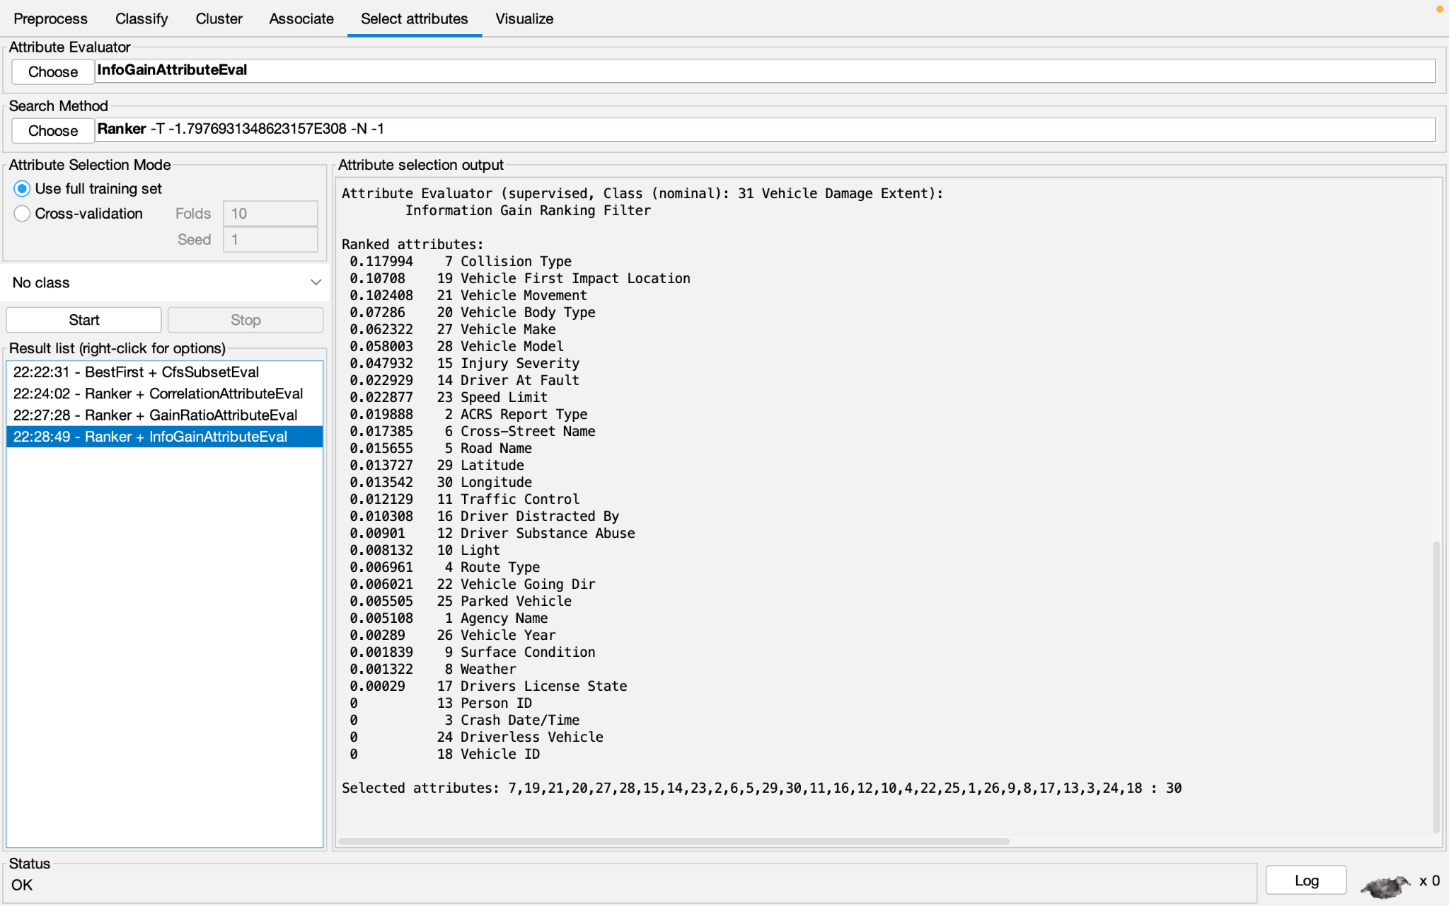

*Note.* Attributes ranked

1. **Gain Ratio:**

We used Weka for this approach. Gain Ratio calculates the information gain of each attribute in the dataset; however, to account for the bias caused by an attribute having many distinct values which normally unintentionally increases the information gain, Gain Ratio divides the information gain by the split information, which is a measure of the complexity of an attribute, to create a less biased output. For our dataset, we used a cutoff value of 0.005.

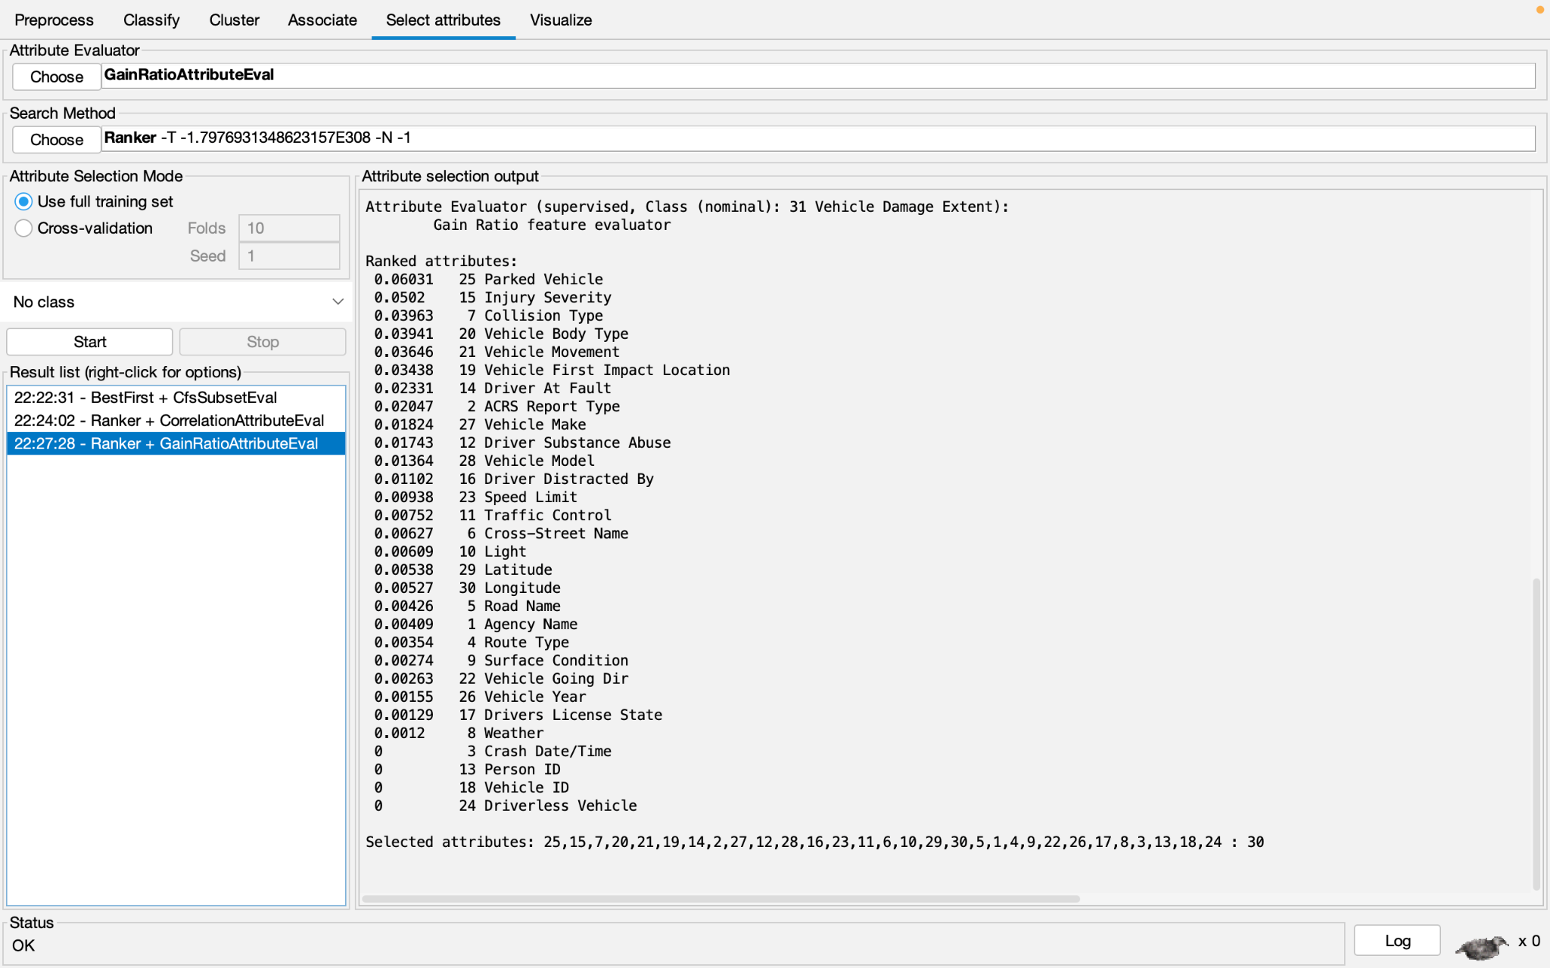

*Note.* Attributes ranked

1. **Correlation:**

We used Weka for this approach. The Correlation Ranking Filter utilizes the Pearson correlation with the class label to rank the attributes. The Pearson correlation is calculated through the following formula: 

For our dataset, we used a cutoff value of 0.0255.

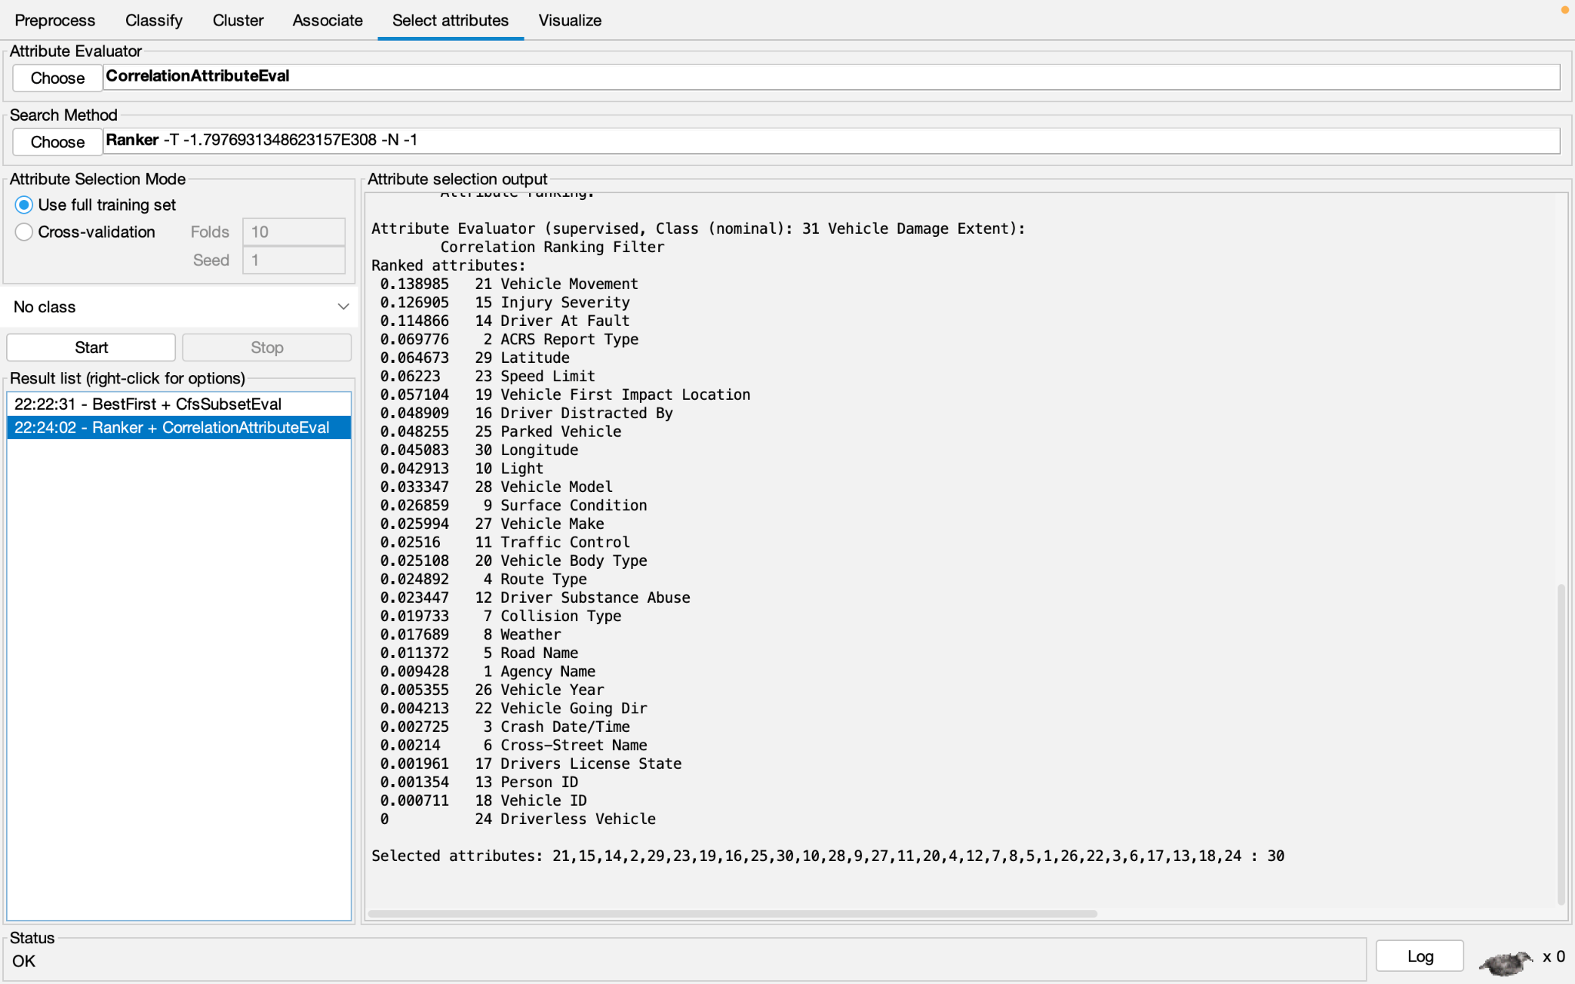

*Note.* Attributes ranked

1. **Correlation-based Feature Selection:**

We used Weka for this approach. The Correlation-based Feature Selection (CFS) utilizes the same Pearson correlation of a feature to the class label as the previous Correlation ranking filter above. However, the distinction between the Correlation ranking filter and CFS is that CFS also analyzes the Pearson correlation between different attributes, prioritizing those with low correlation. It will then select the attributes with the highest correlation with the label and lowest correlations with each other.

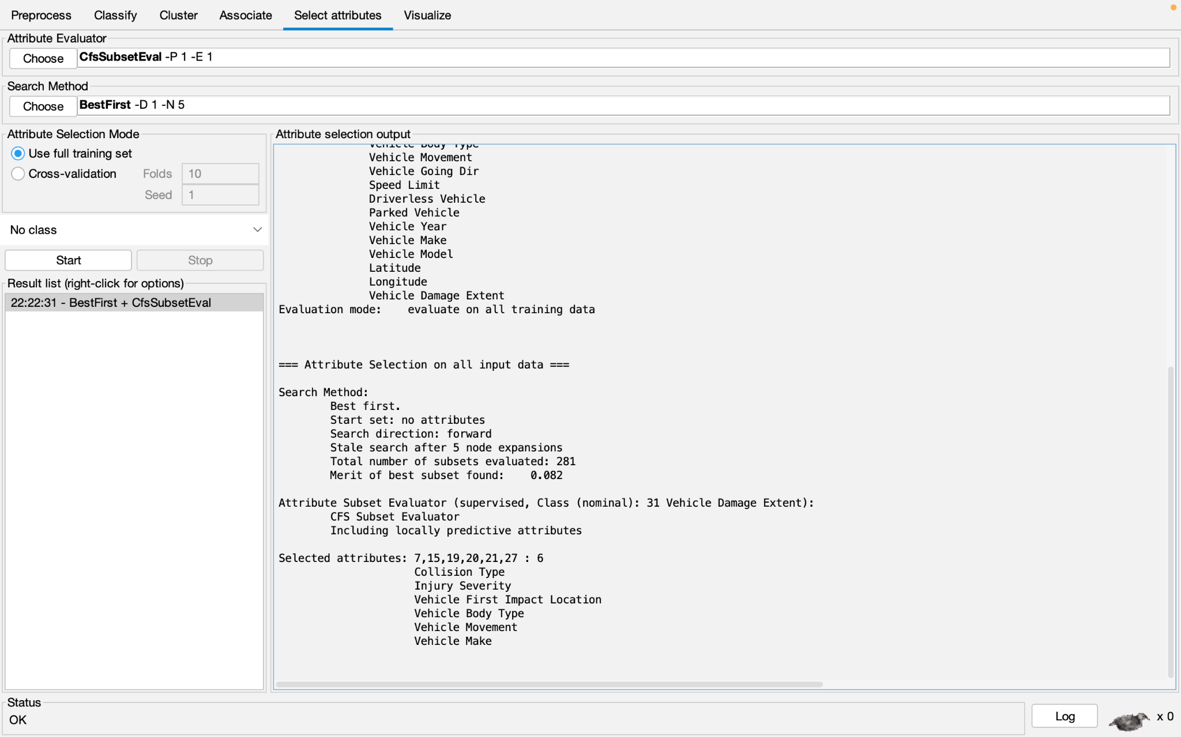

*Note.* Attributes selected

**Part 5: Training and Analysis**

Using each of the subsets created by the 5 attribute selection methods above, we ran 4 classification models and tested their accuracy:

1. **J48:**

A decision tree algorithm that makes predictions by splitting the data into smaller groups based on key features. It works well with qualitative or discrete data (e.g., weather or road conditions) as it identifies patterns in vehicle damage and understands what features matter most, like how specific conditions increase the chance of severe damage.

* 1. **Non-Weka:**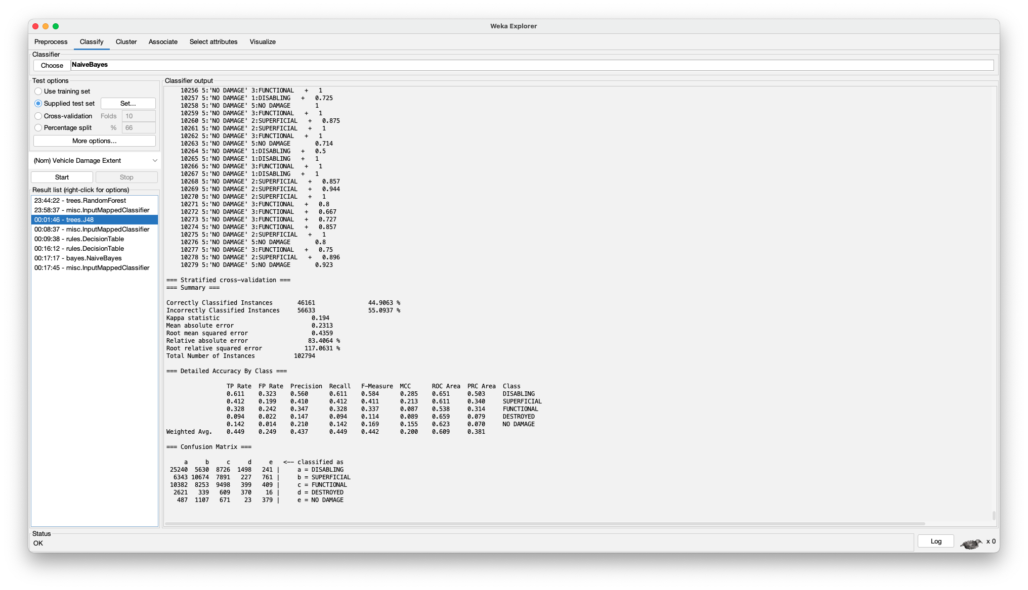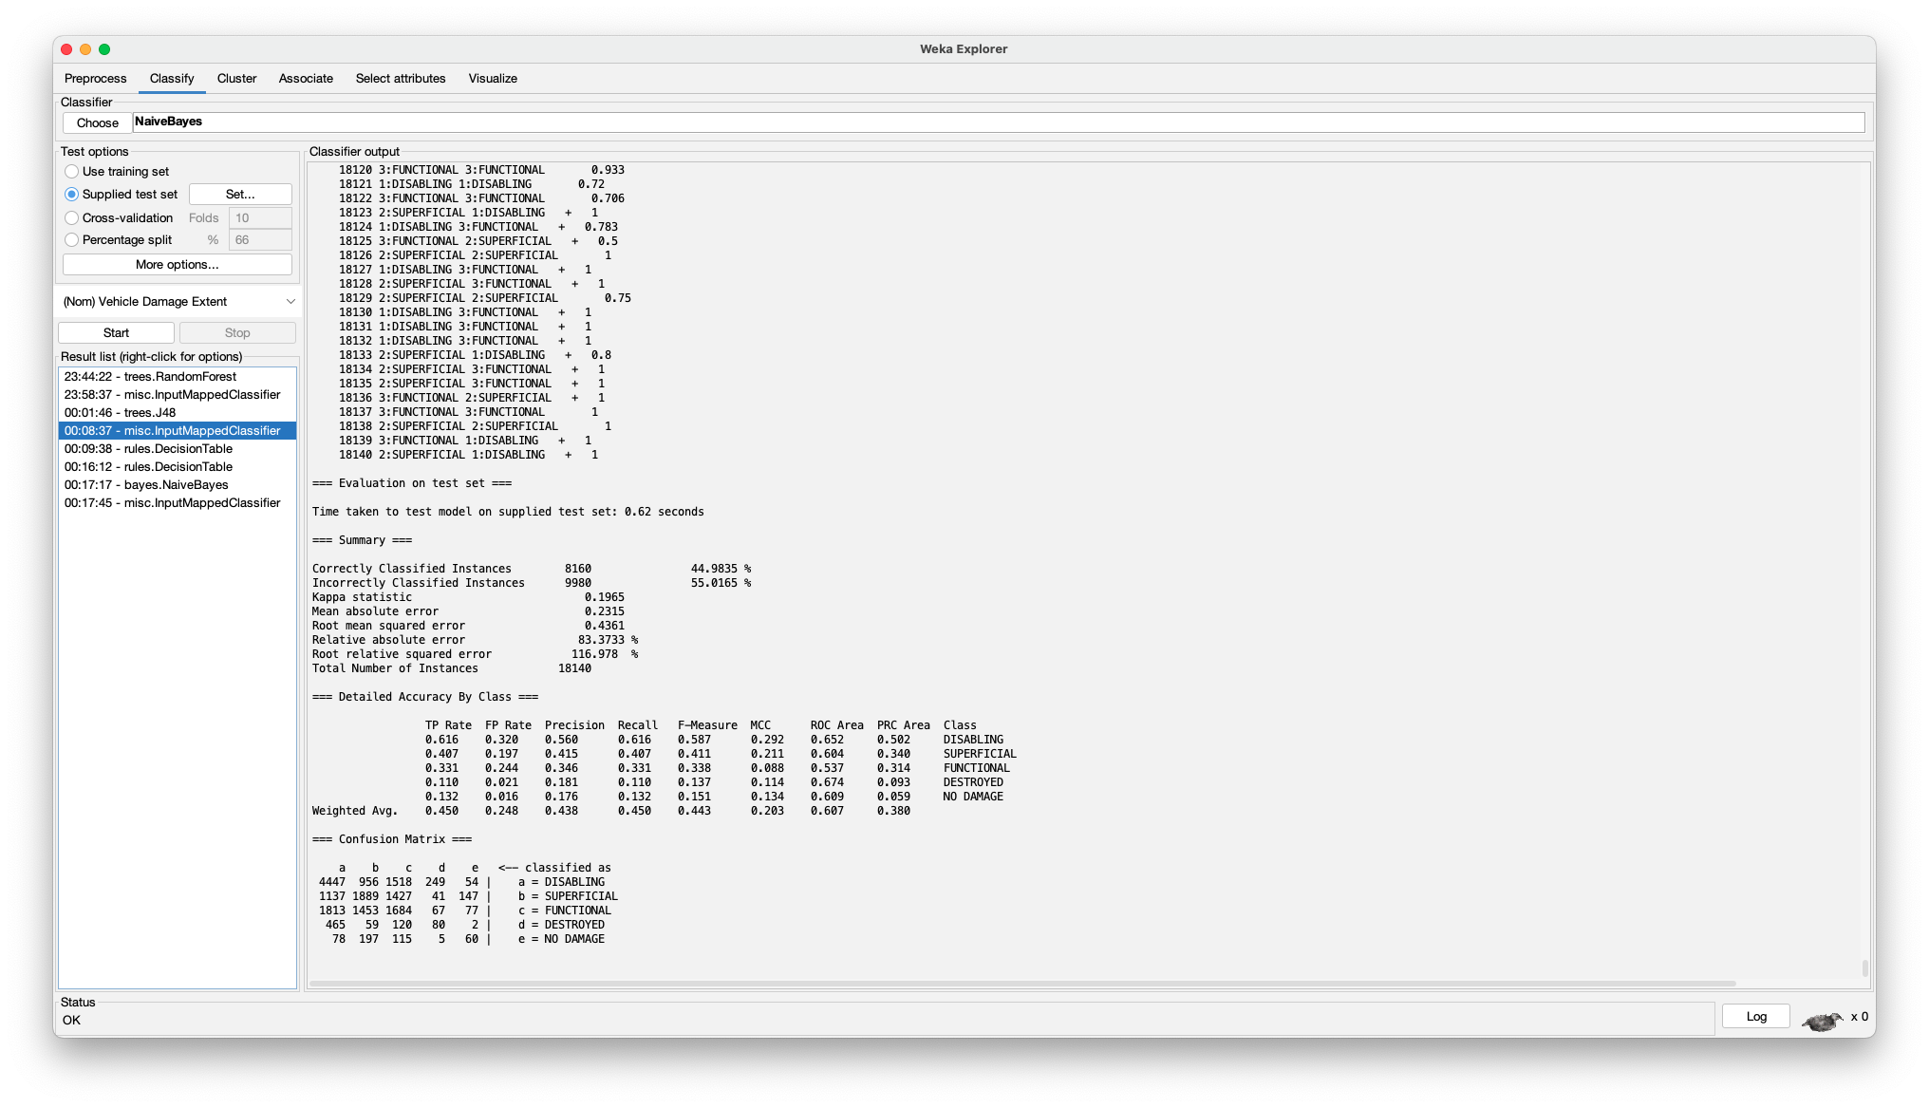
  2. **Information Gain:** 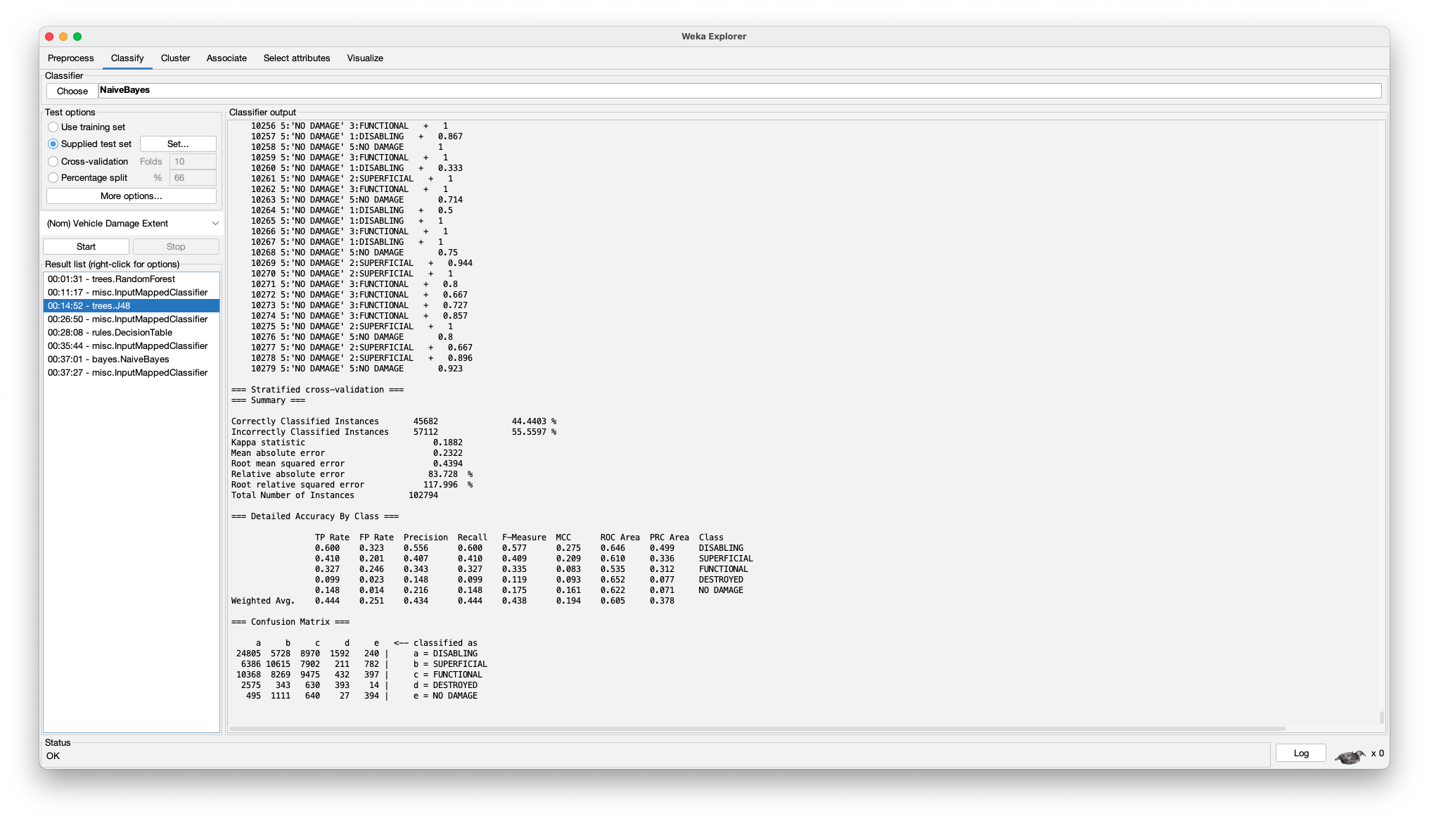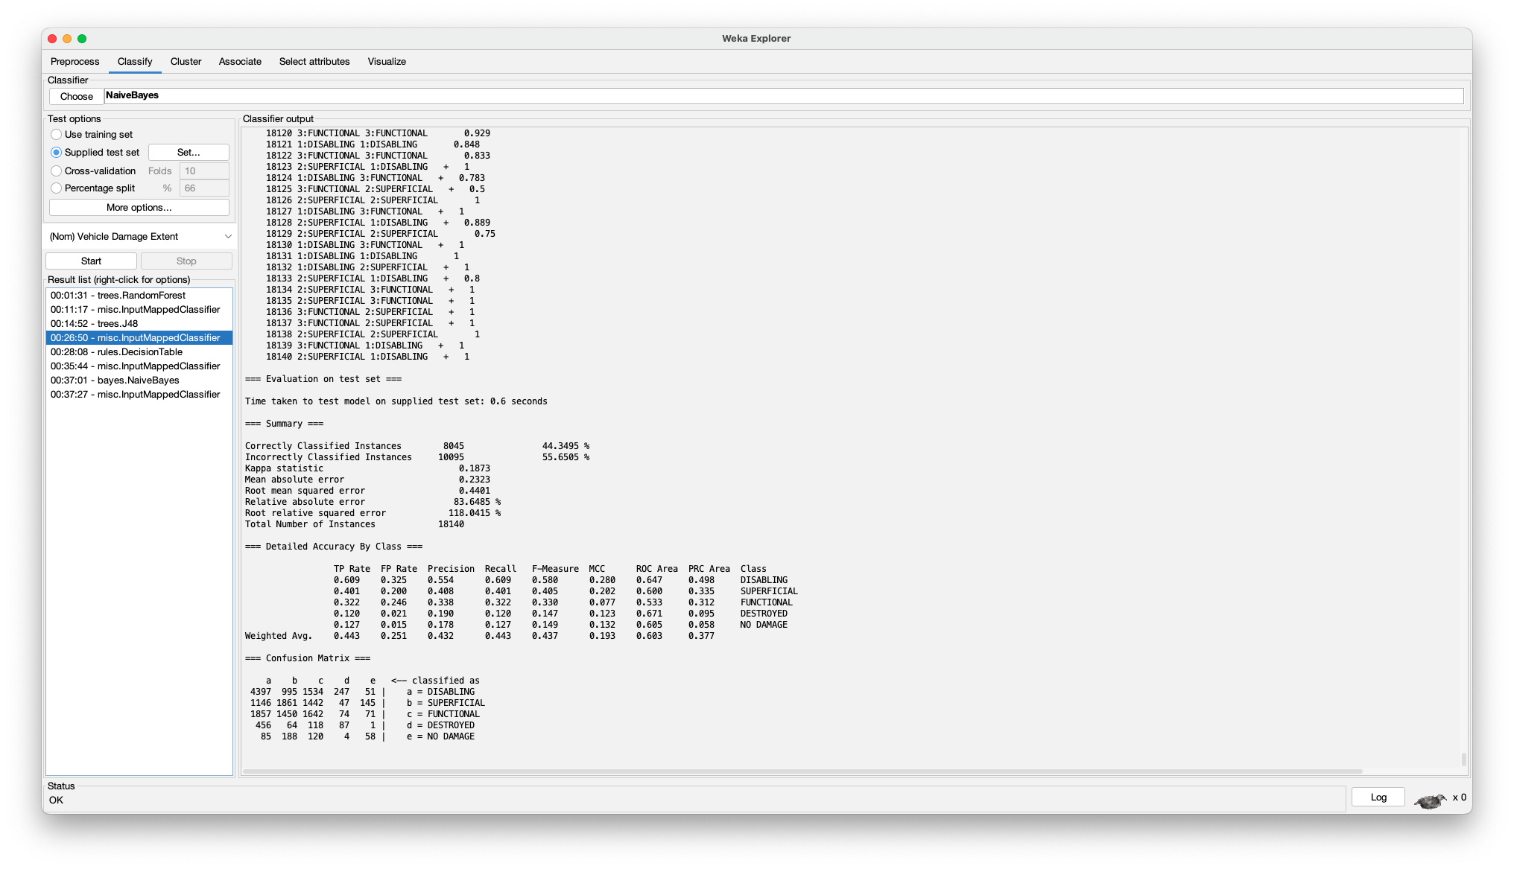
  3. **Gain Ratio:**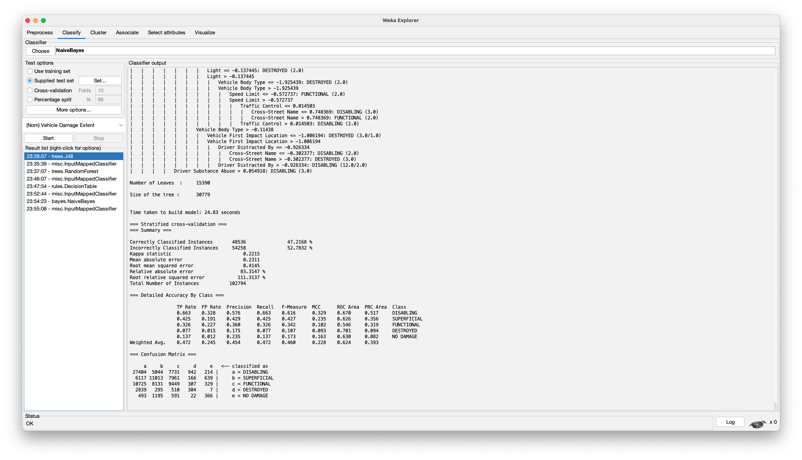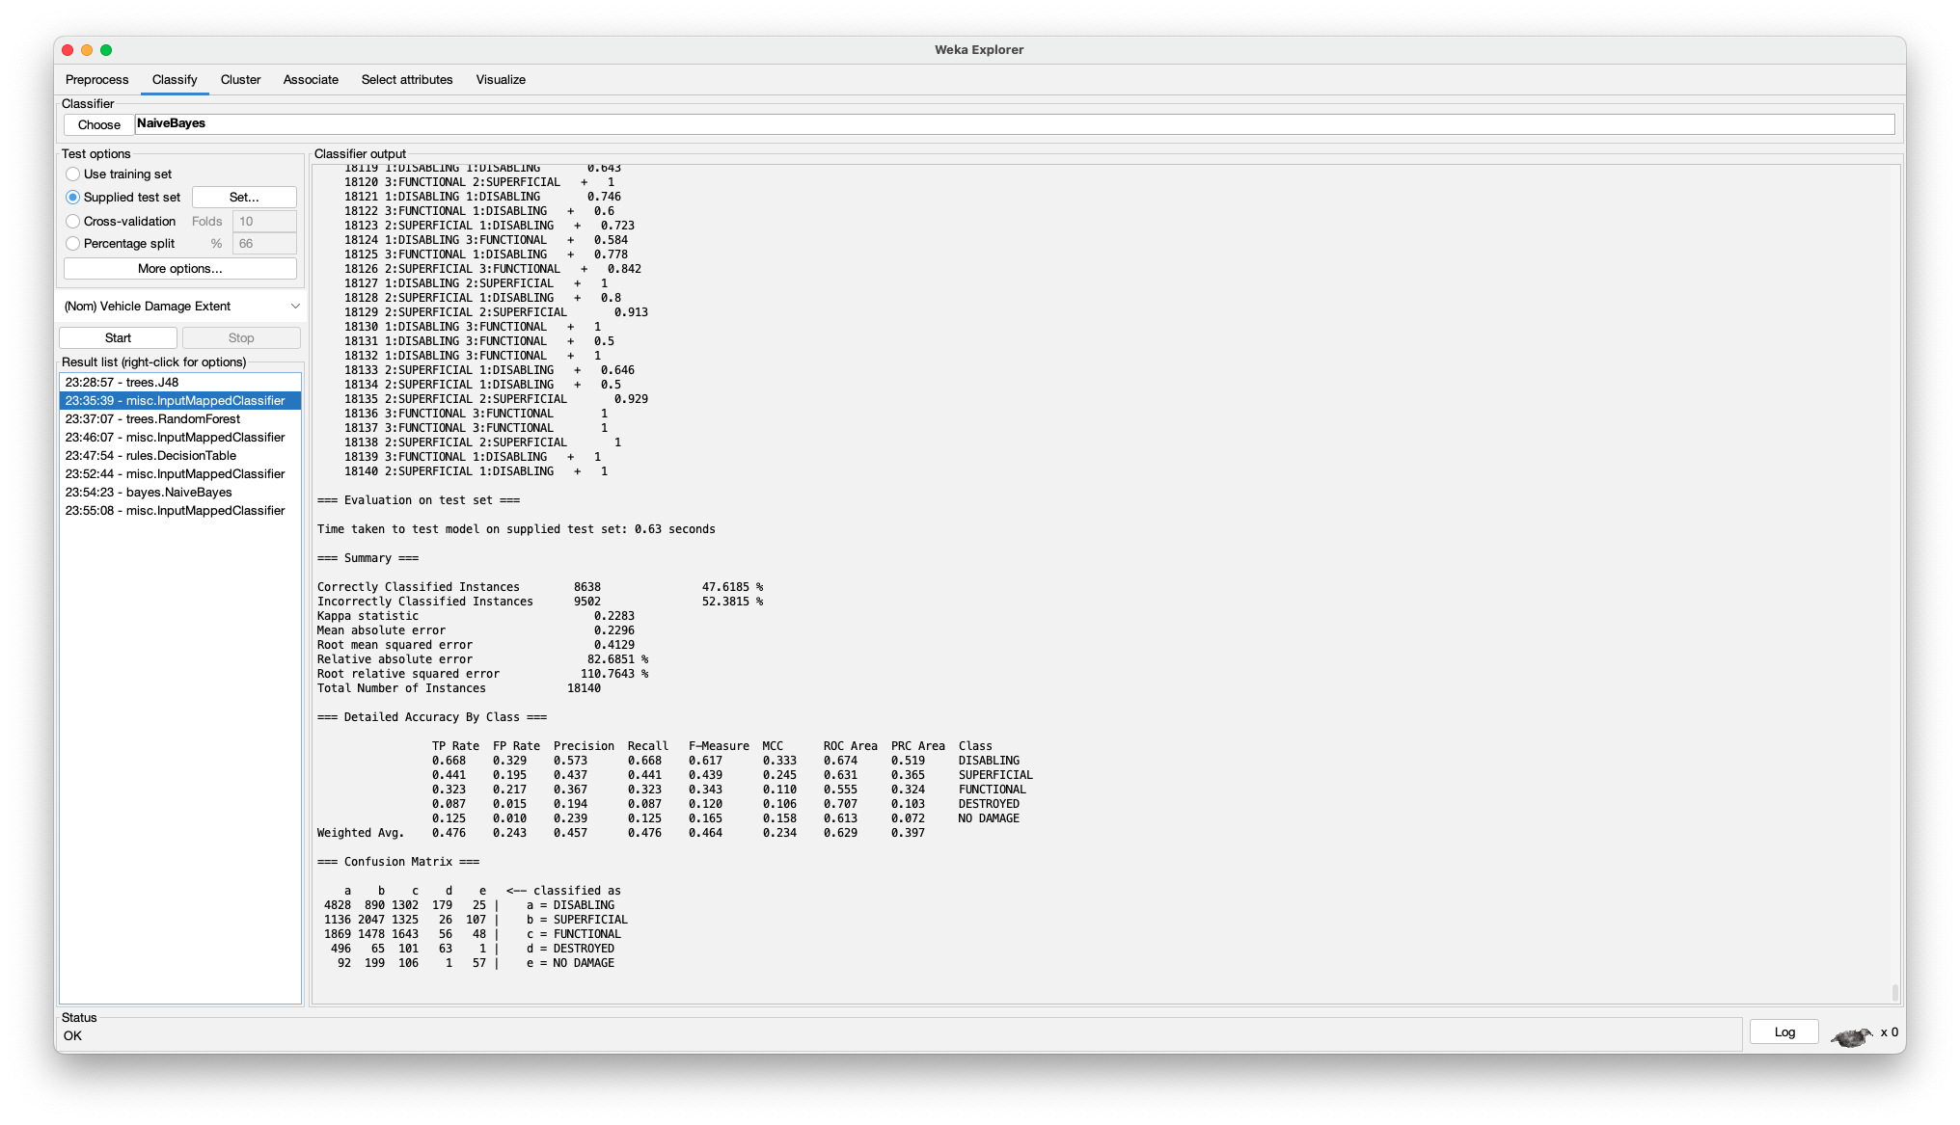
  4. **Correlation:**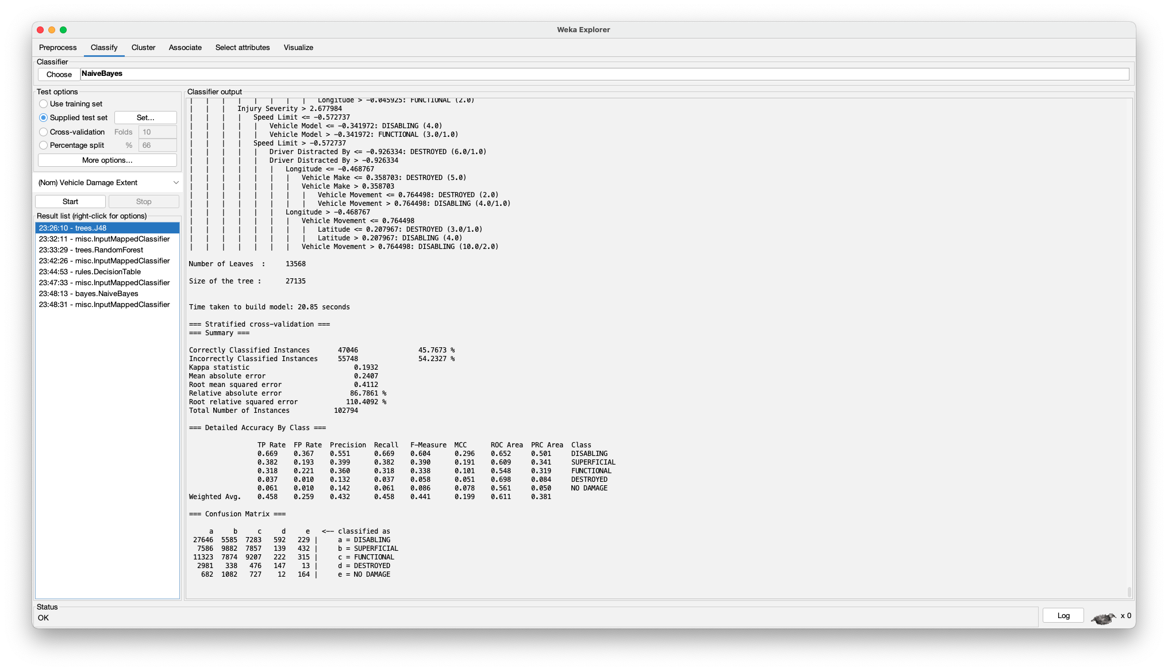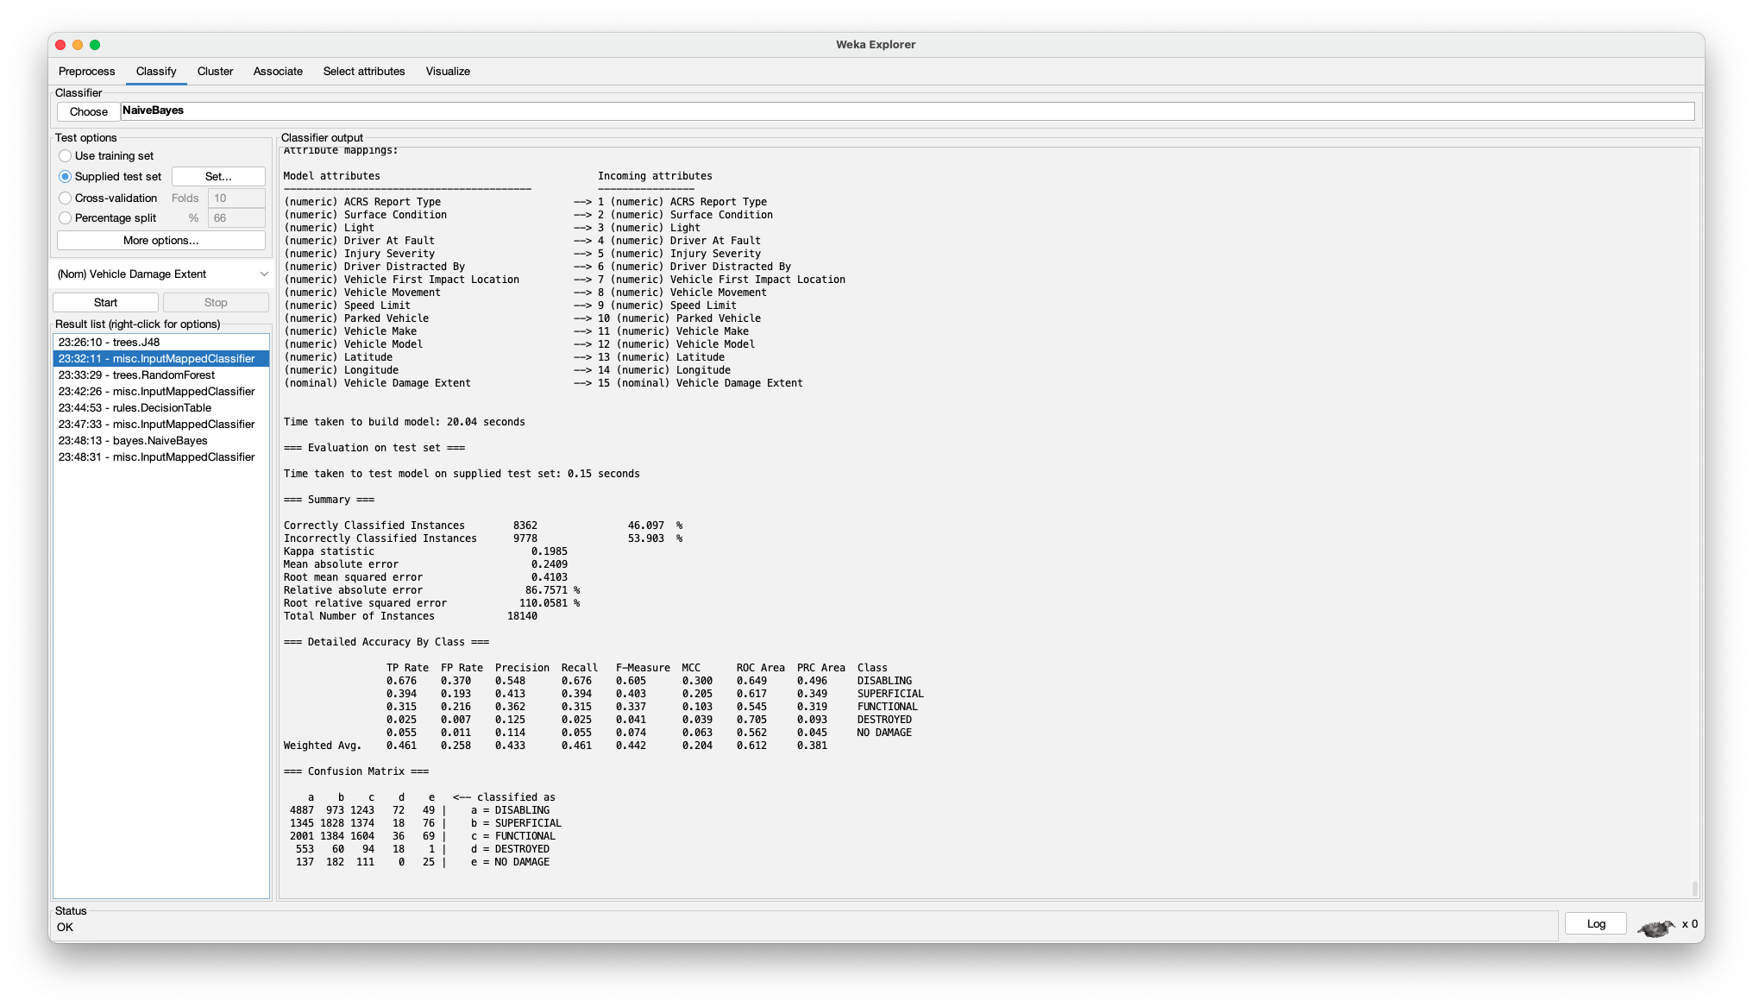
  5. **Correlation-based Feature Selection:**

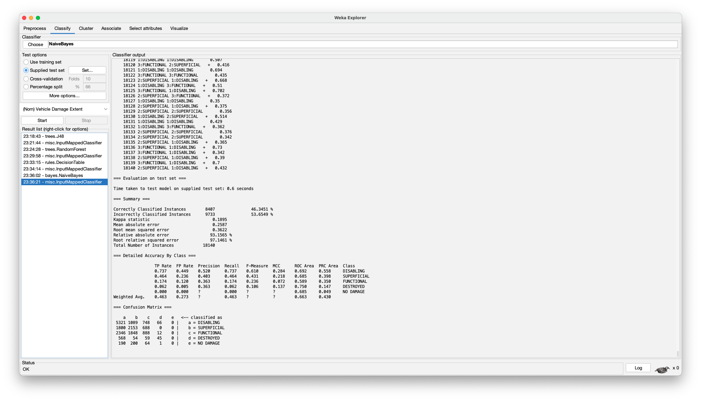

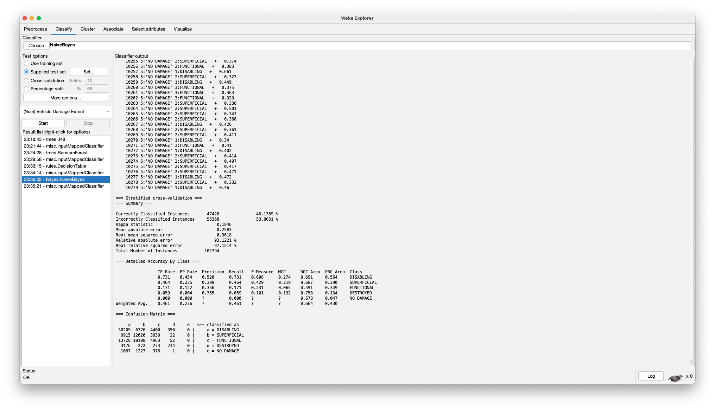

1. **Decision Table:**

Decision table is a type of classifier that builds a table of rules based on training data and tries to match new test data according to the “rules” established in the aforementioned table. These models are useful as they can account for non-linear relationships and don’t require an incredibly large amount of data, but they also have some drawbacks: namely, they tend to overfit.

* 1. **Non-Weka:**

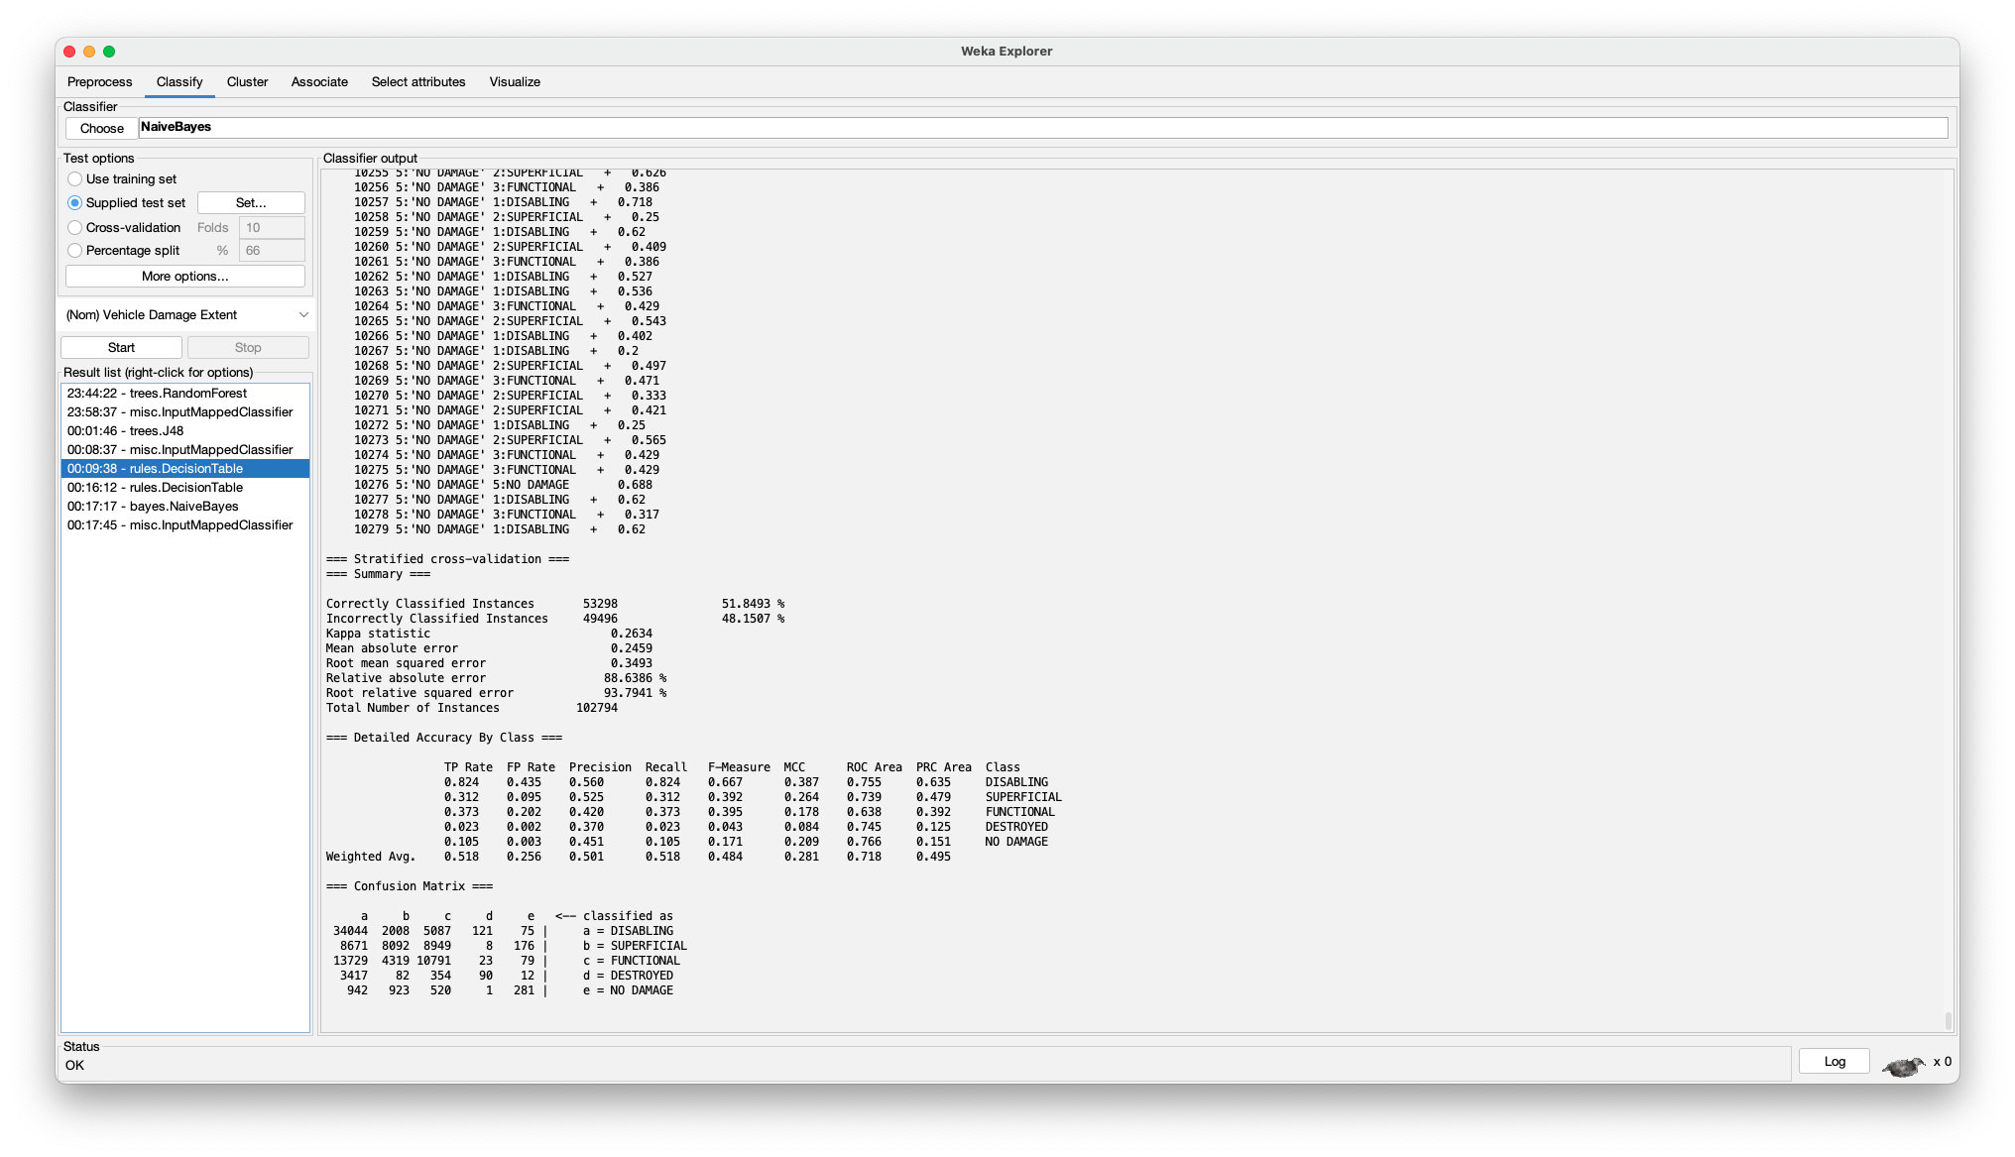

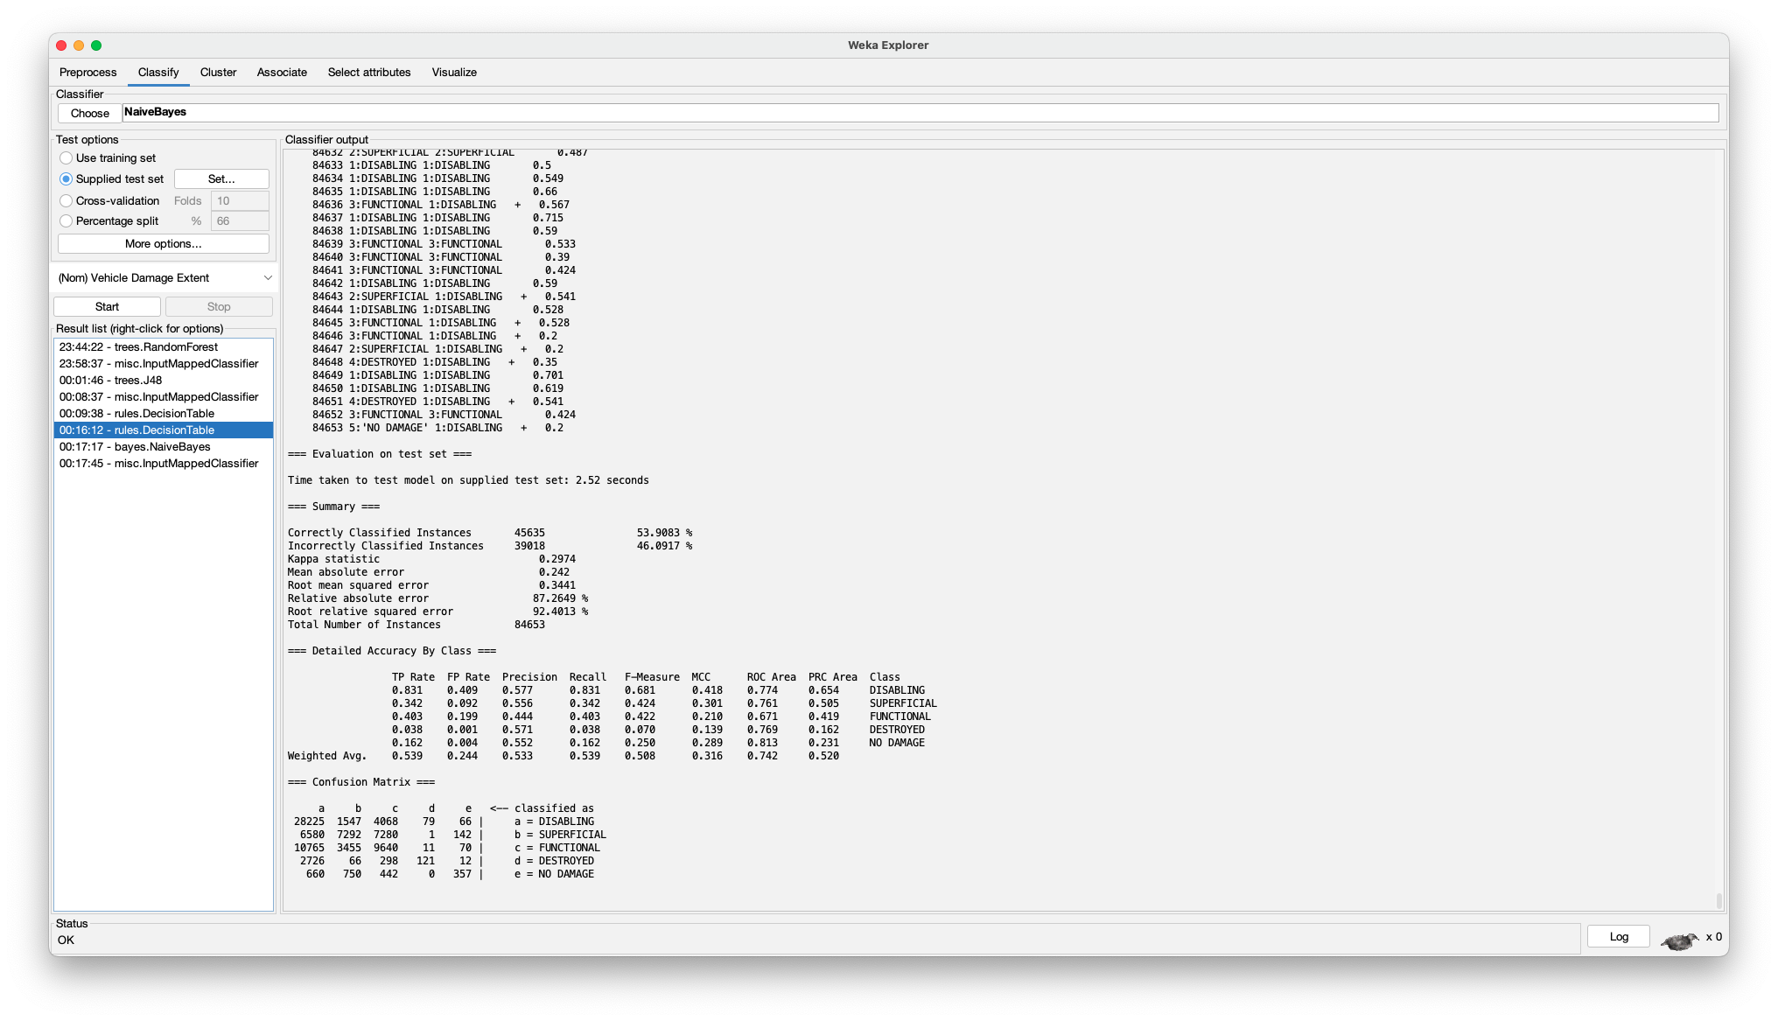

* 1. **Information Gain:**

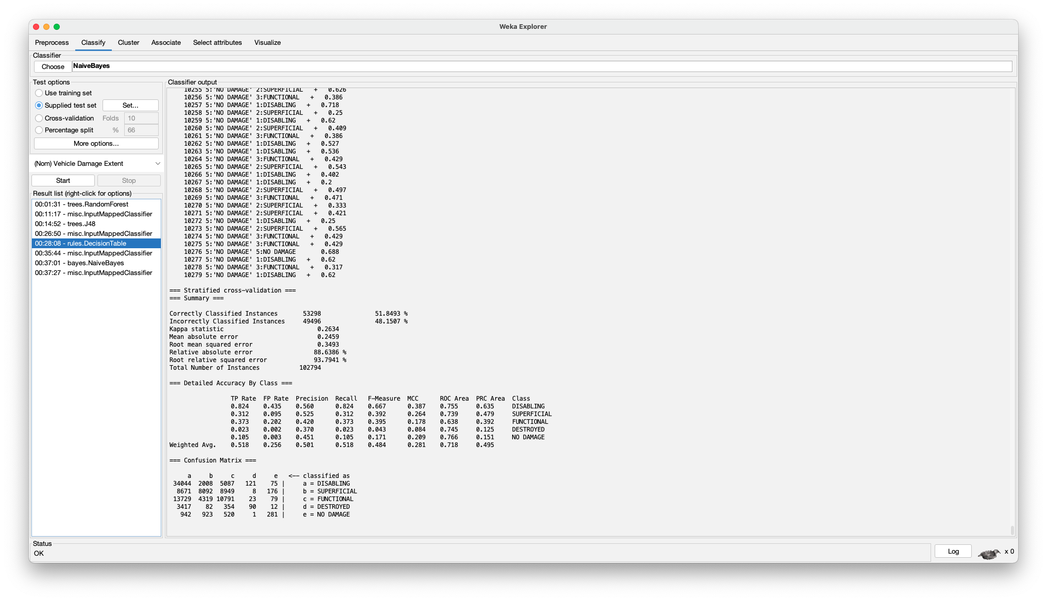

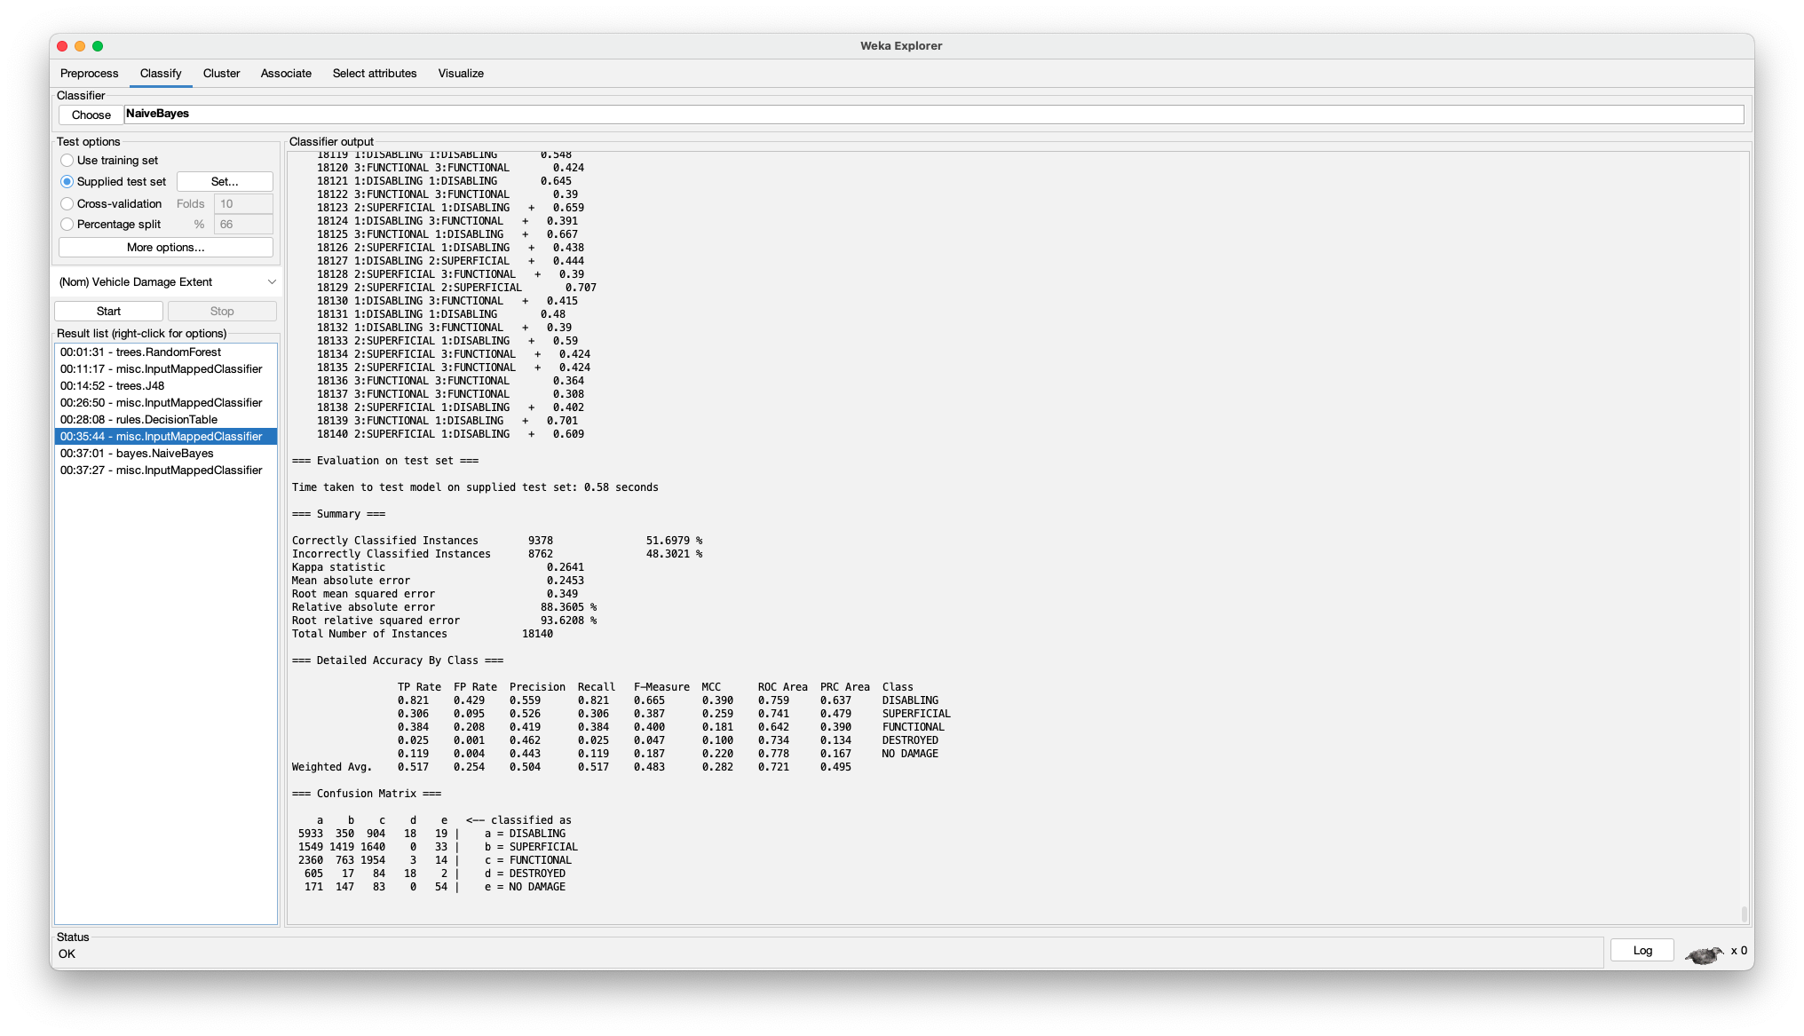

* 1. **Gain Ratio:**

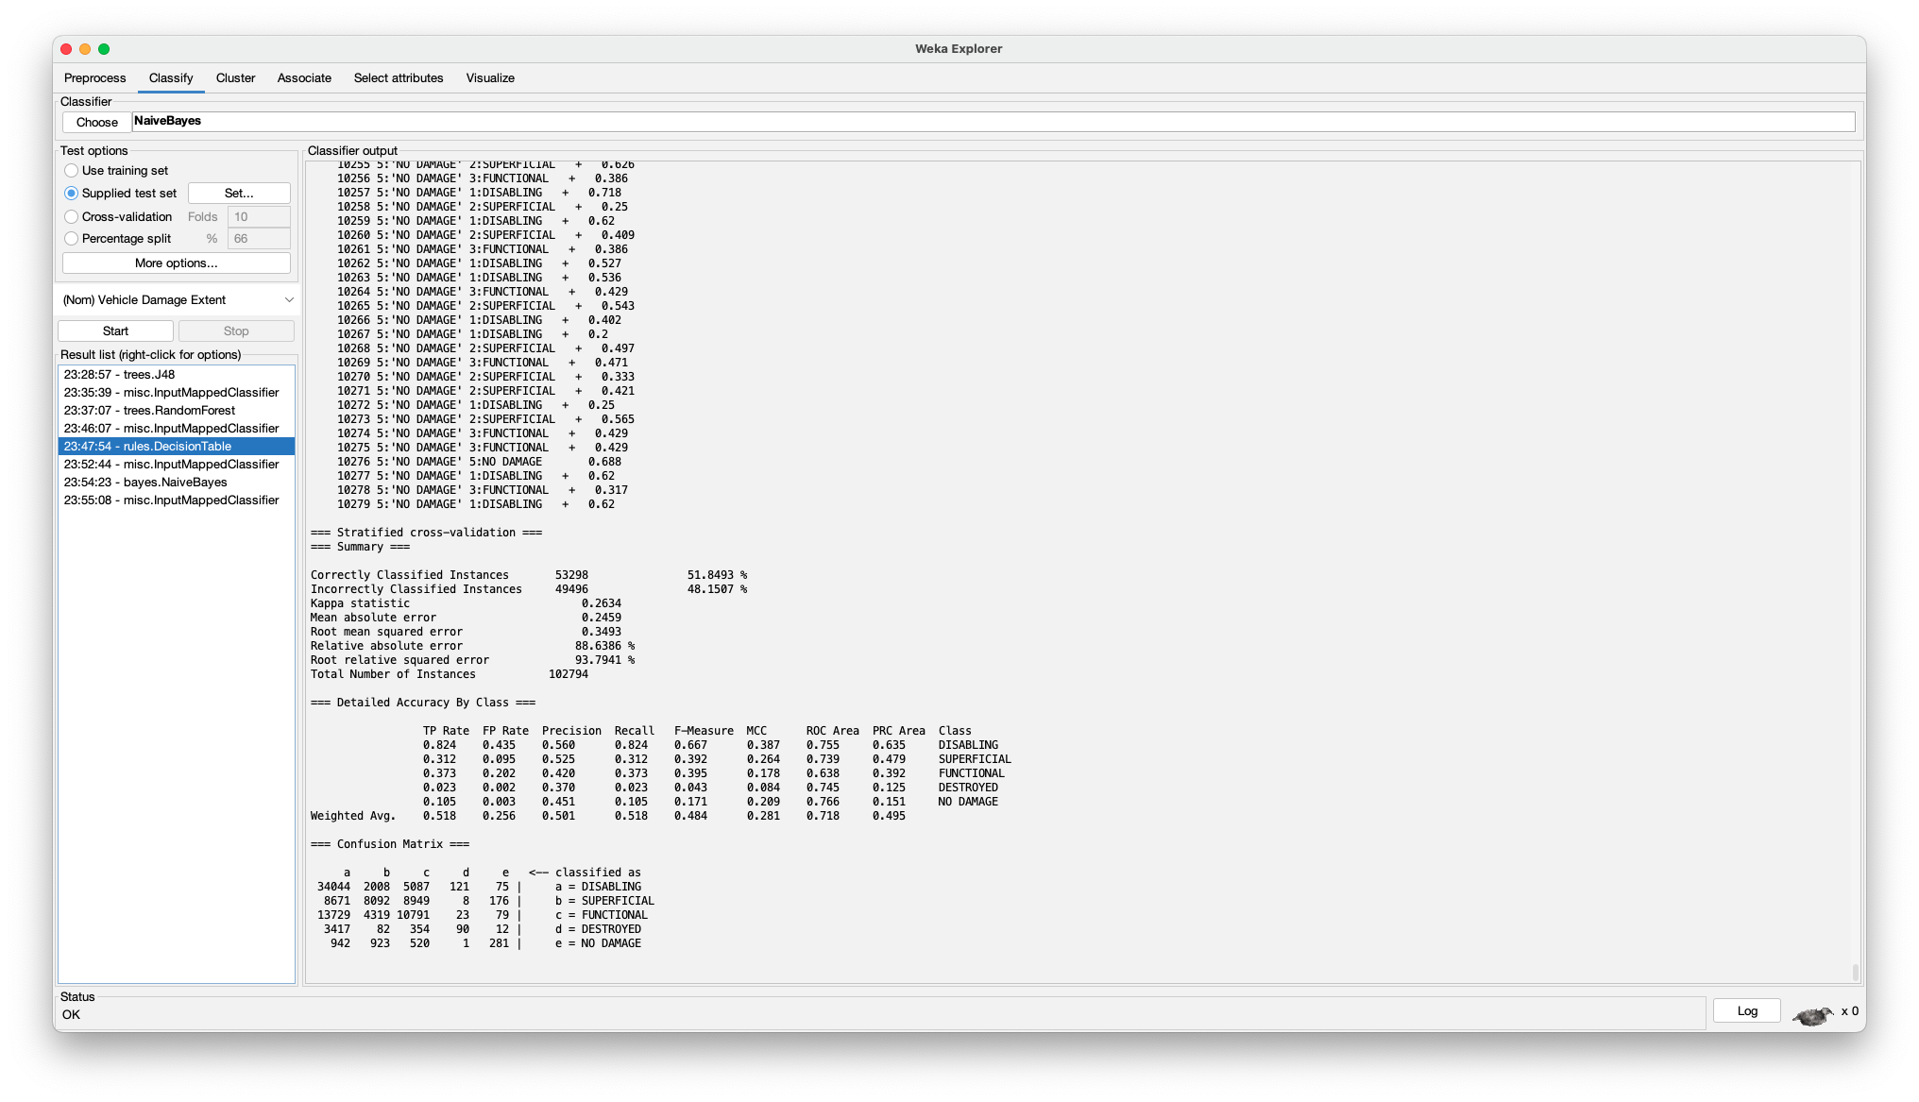

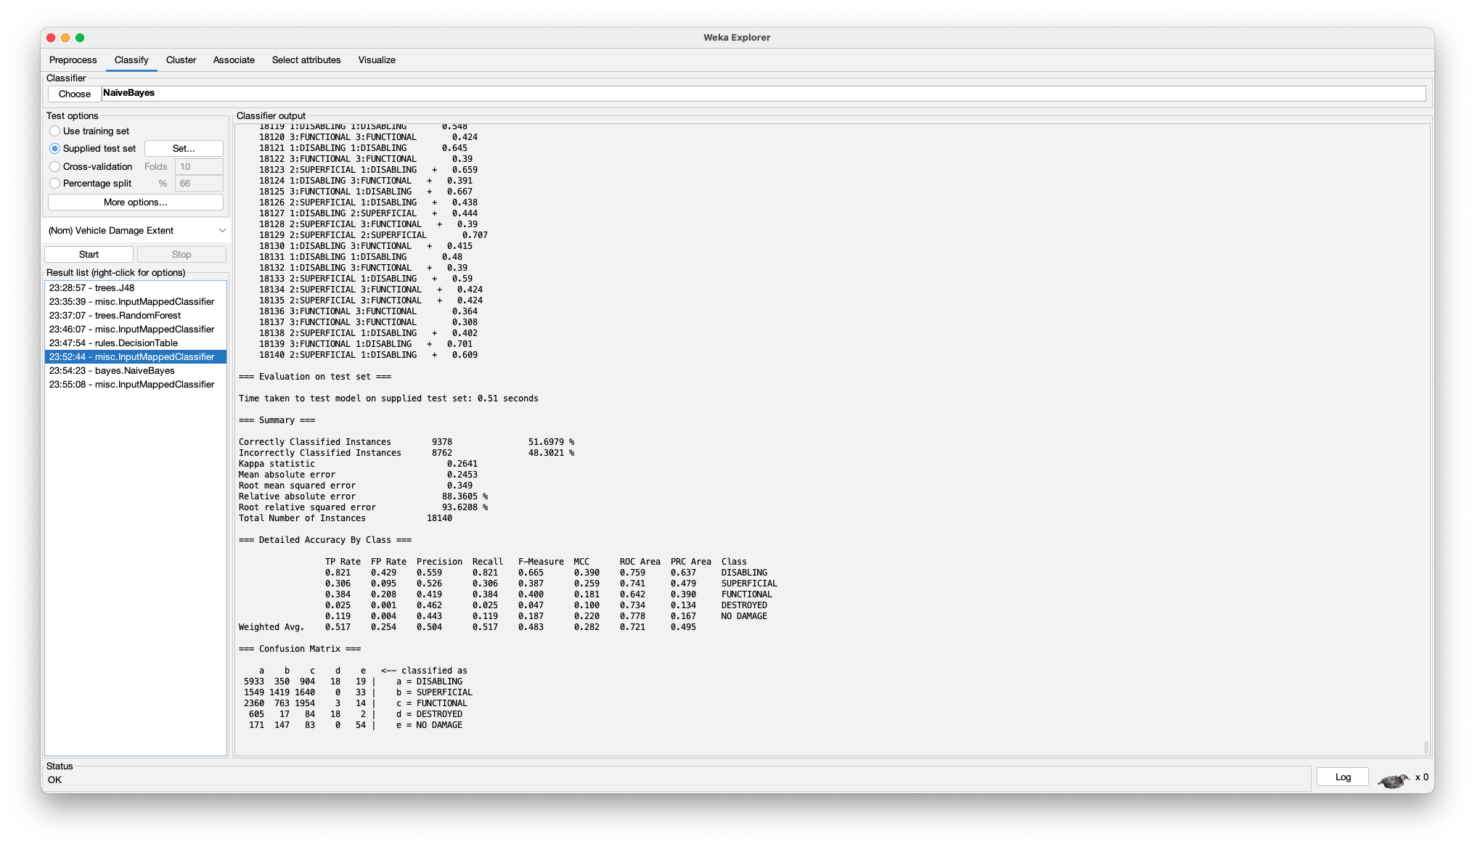

* 1. **Correlation:**

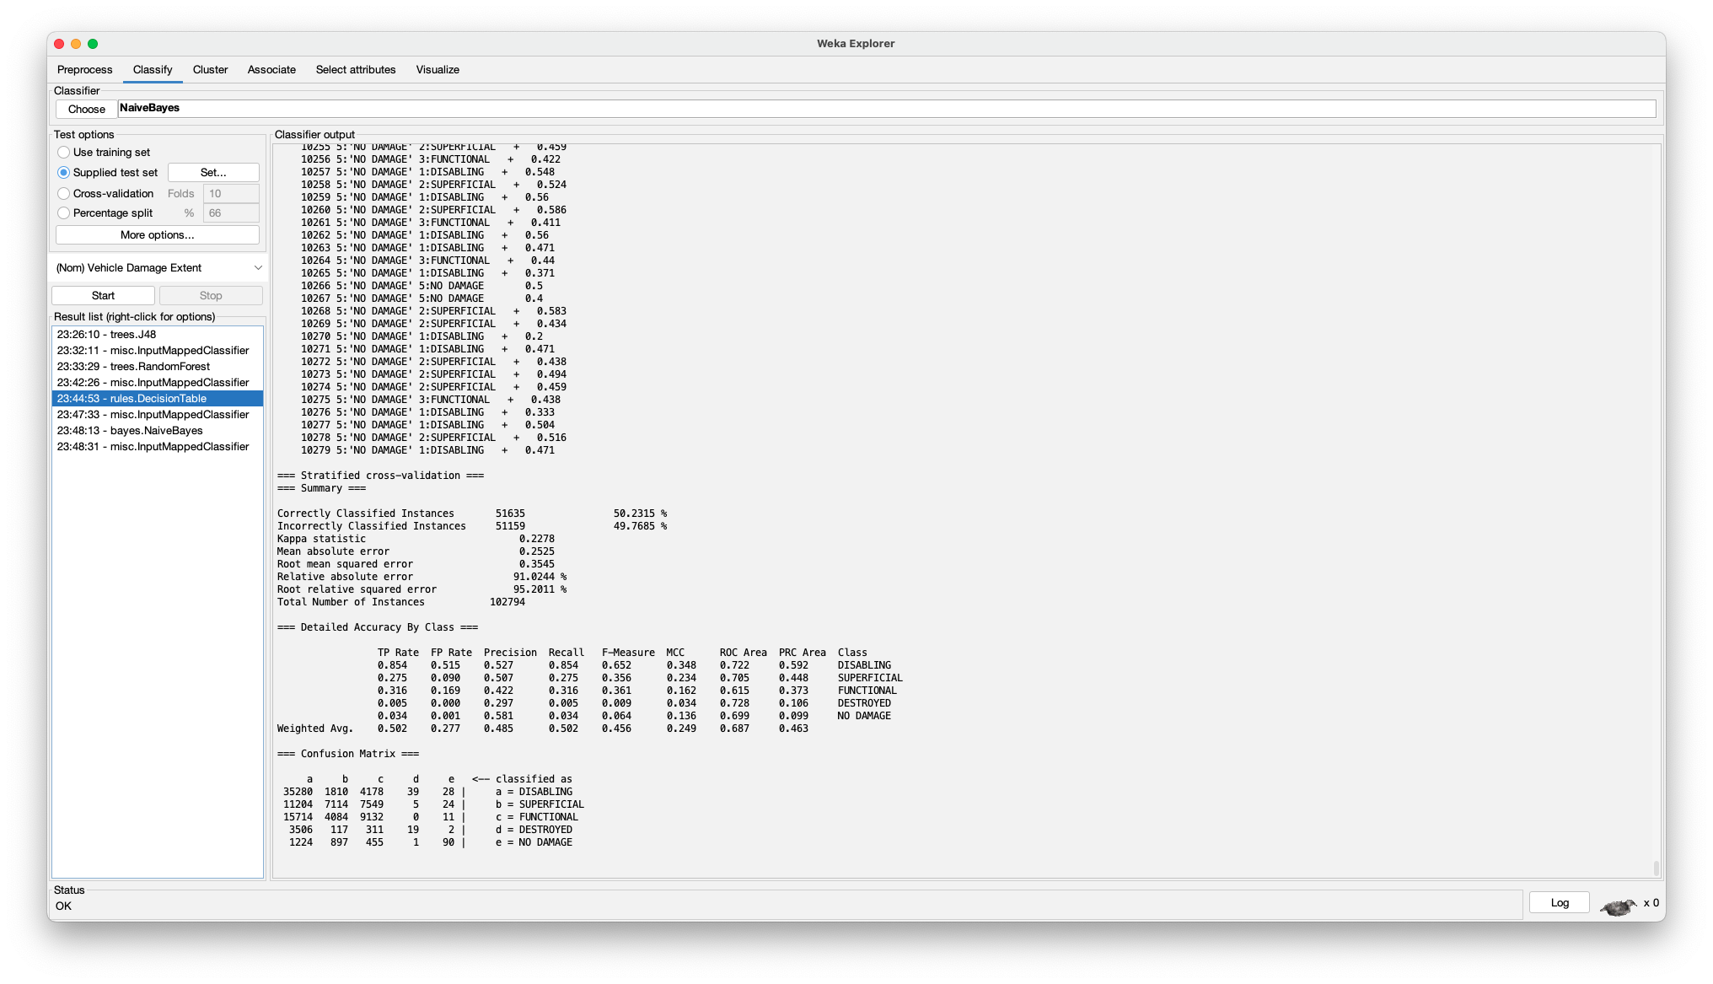

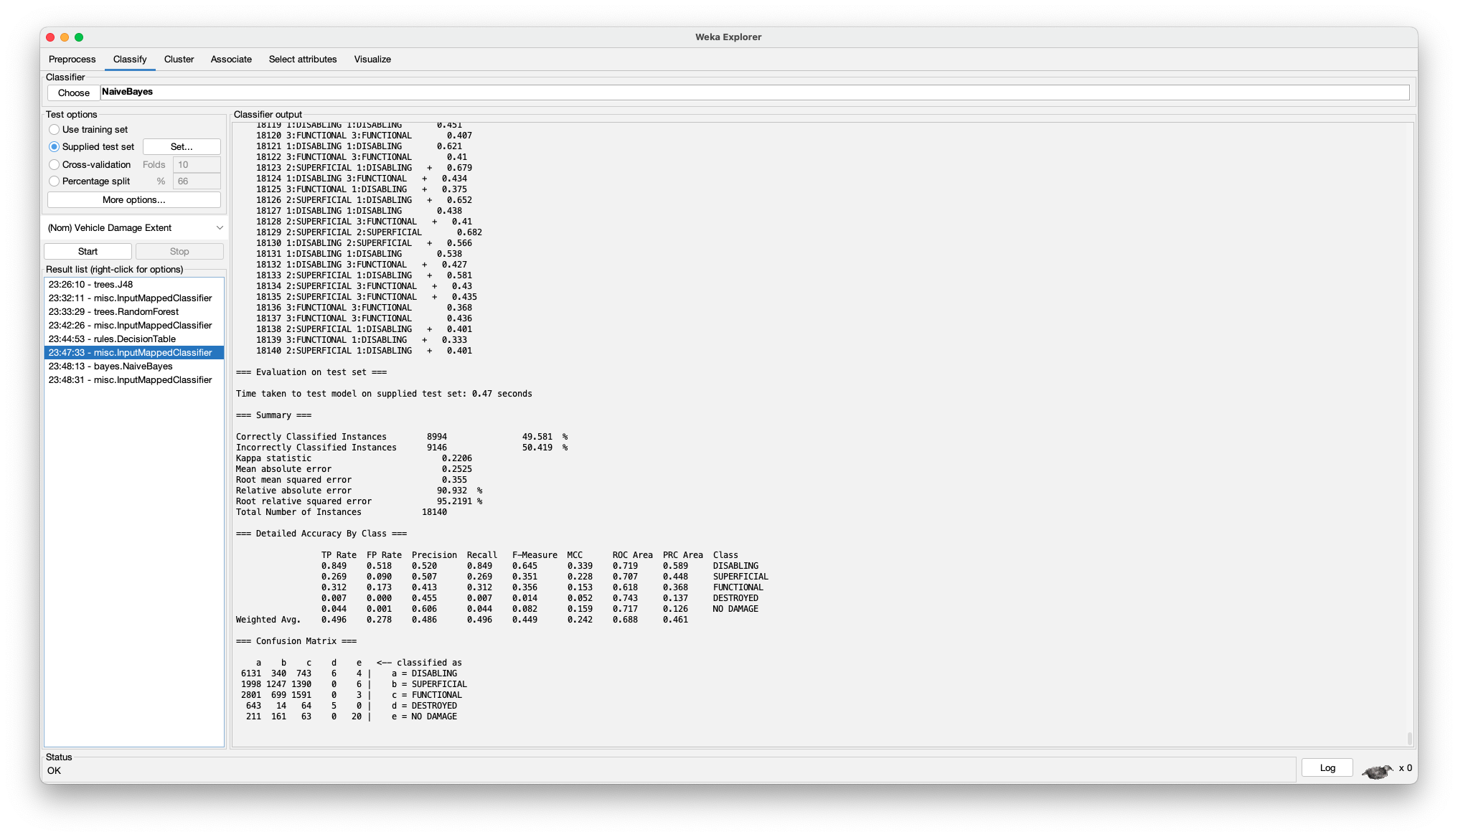

* 1. **Correlation-based Feature Selection:**

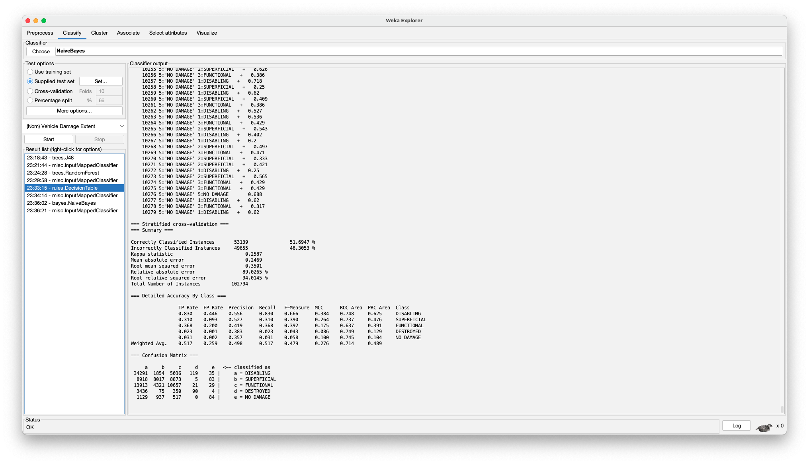

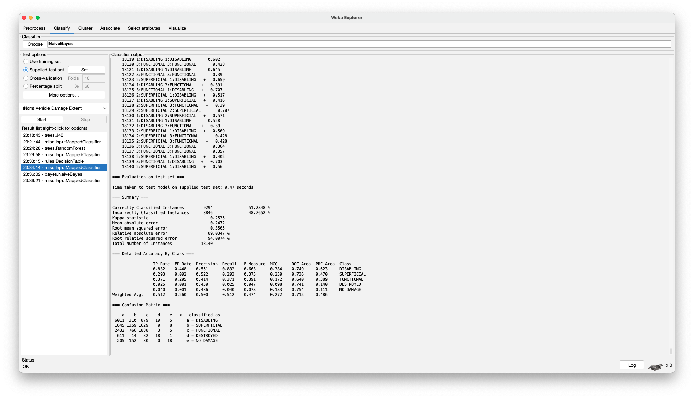

1. **Naïve-Bayes:**

A classifier which utilizes Bayesian probability to determine the class label of an instance. A unique factor of this classifier is that it assumes each attribute to be independent, similar to the OneR classifier.

1. **Non-Weka:**

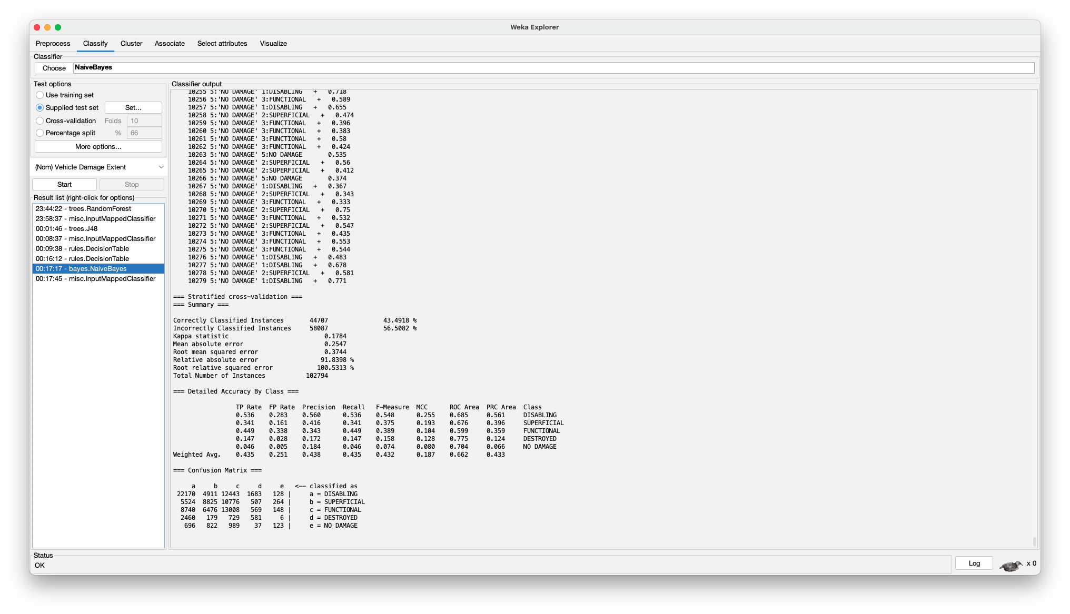

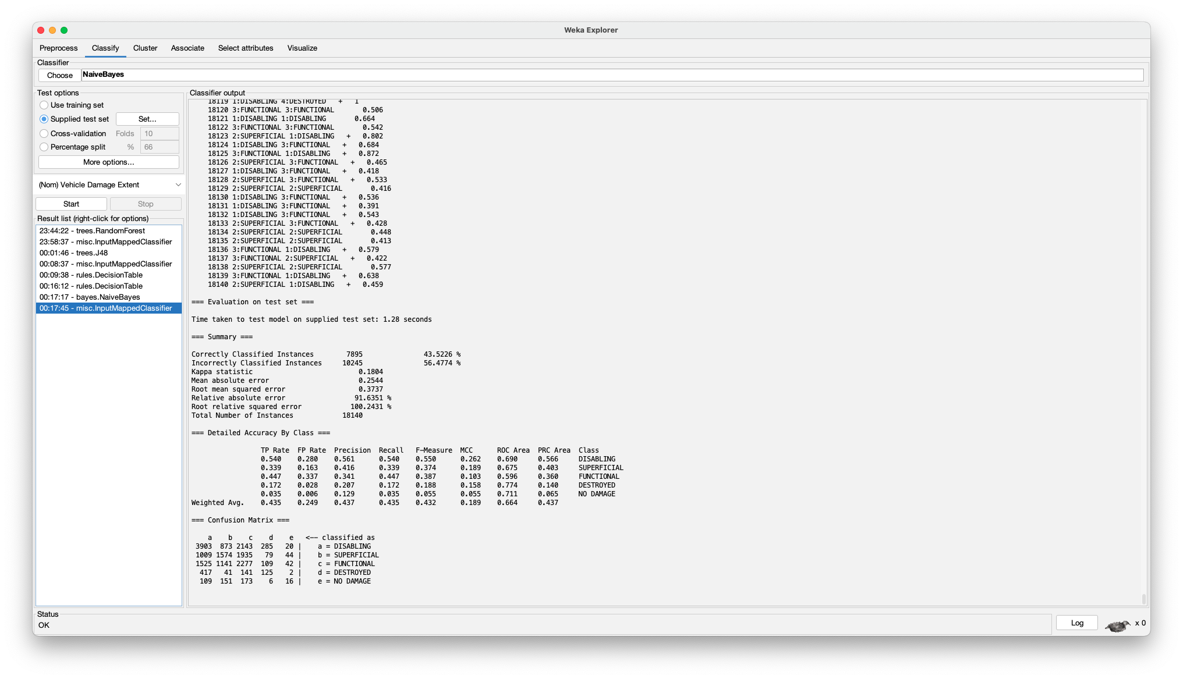

1. **Information Gain:**

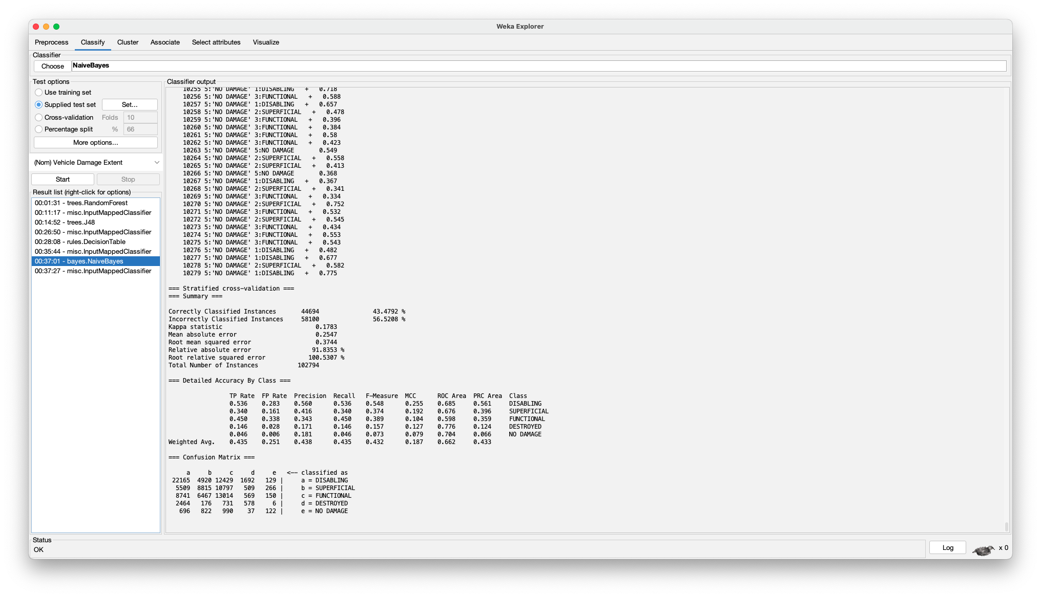

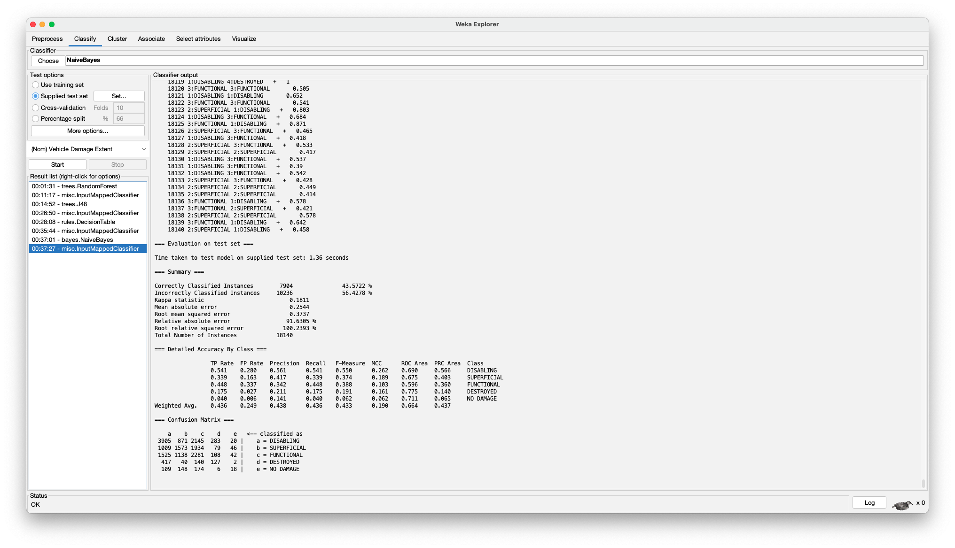

1. **Gain Ratio:**

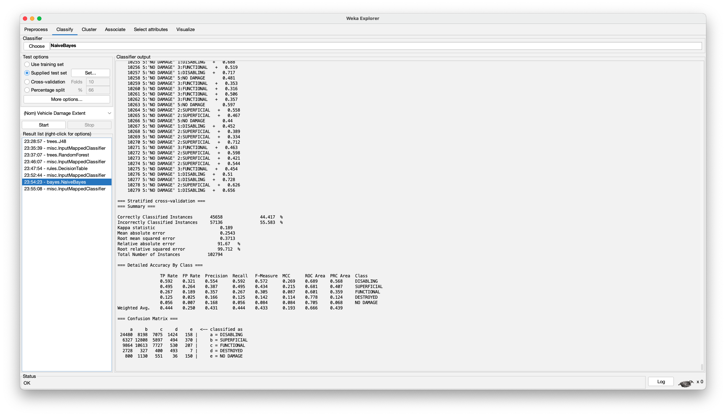

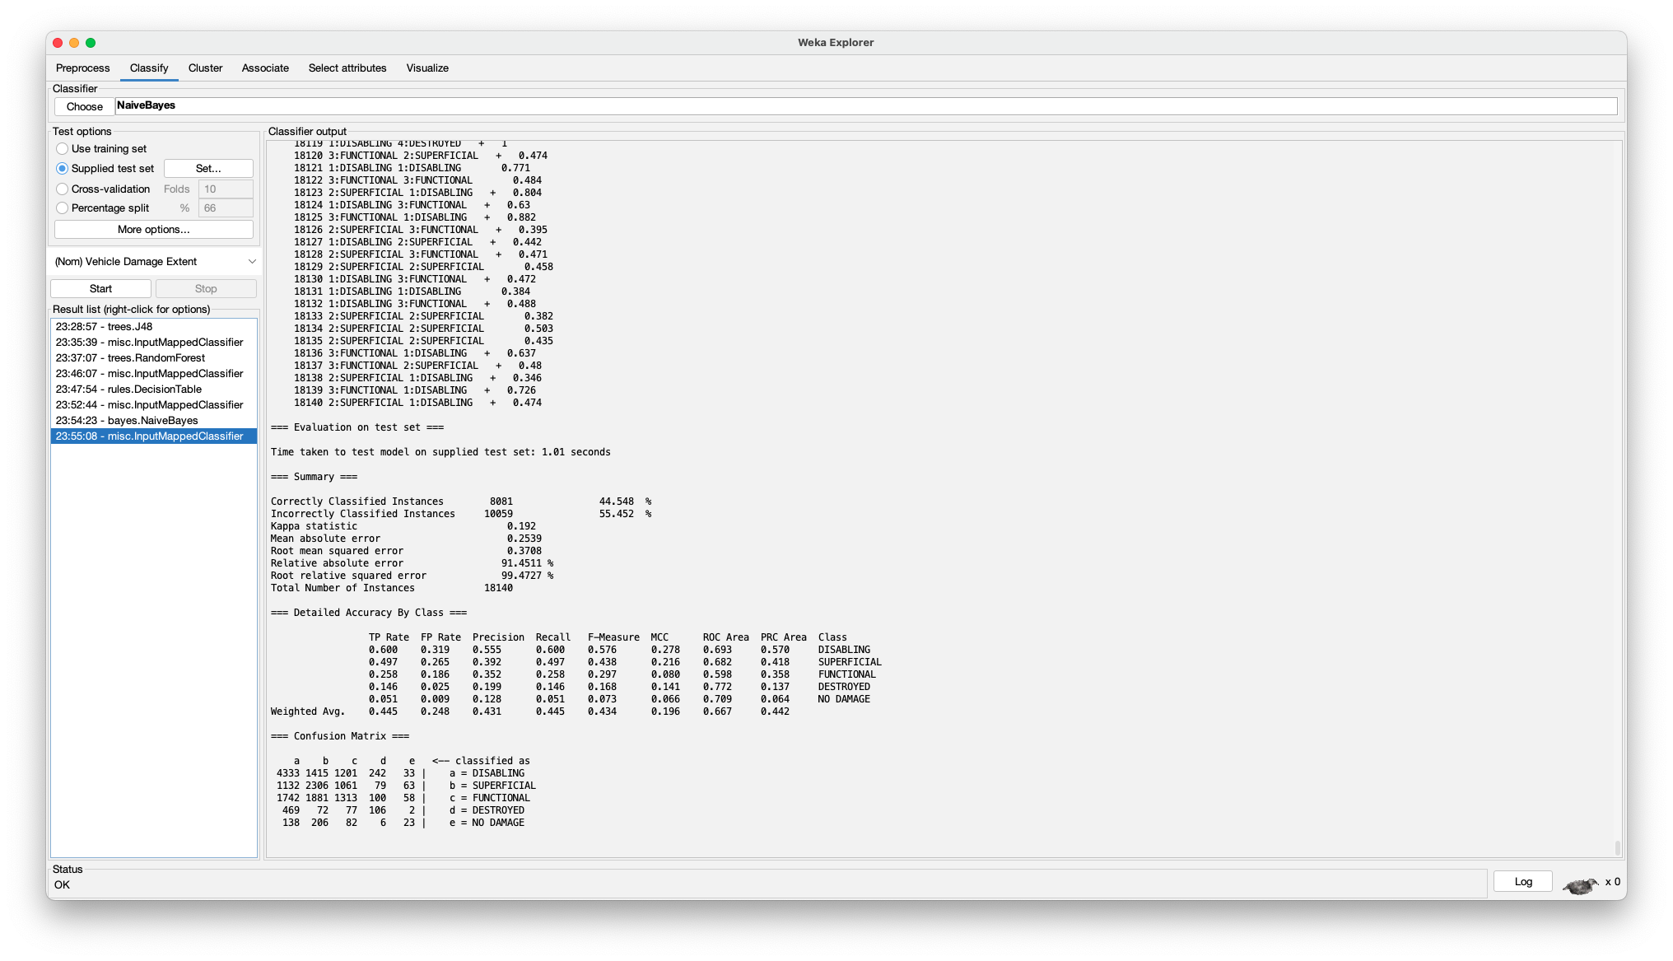

1. **Correlation:**

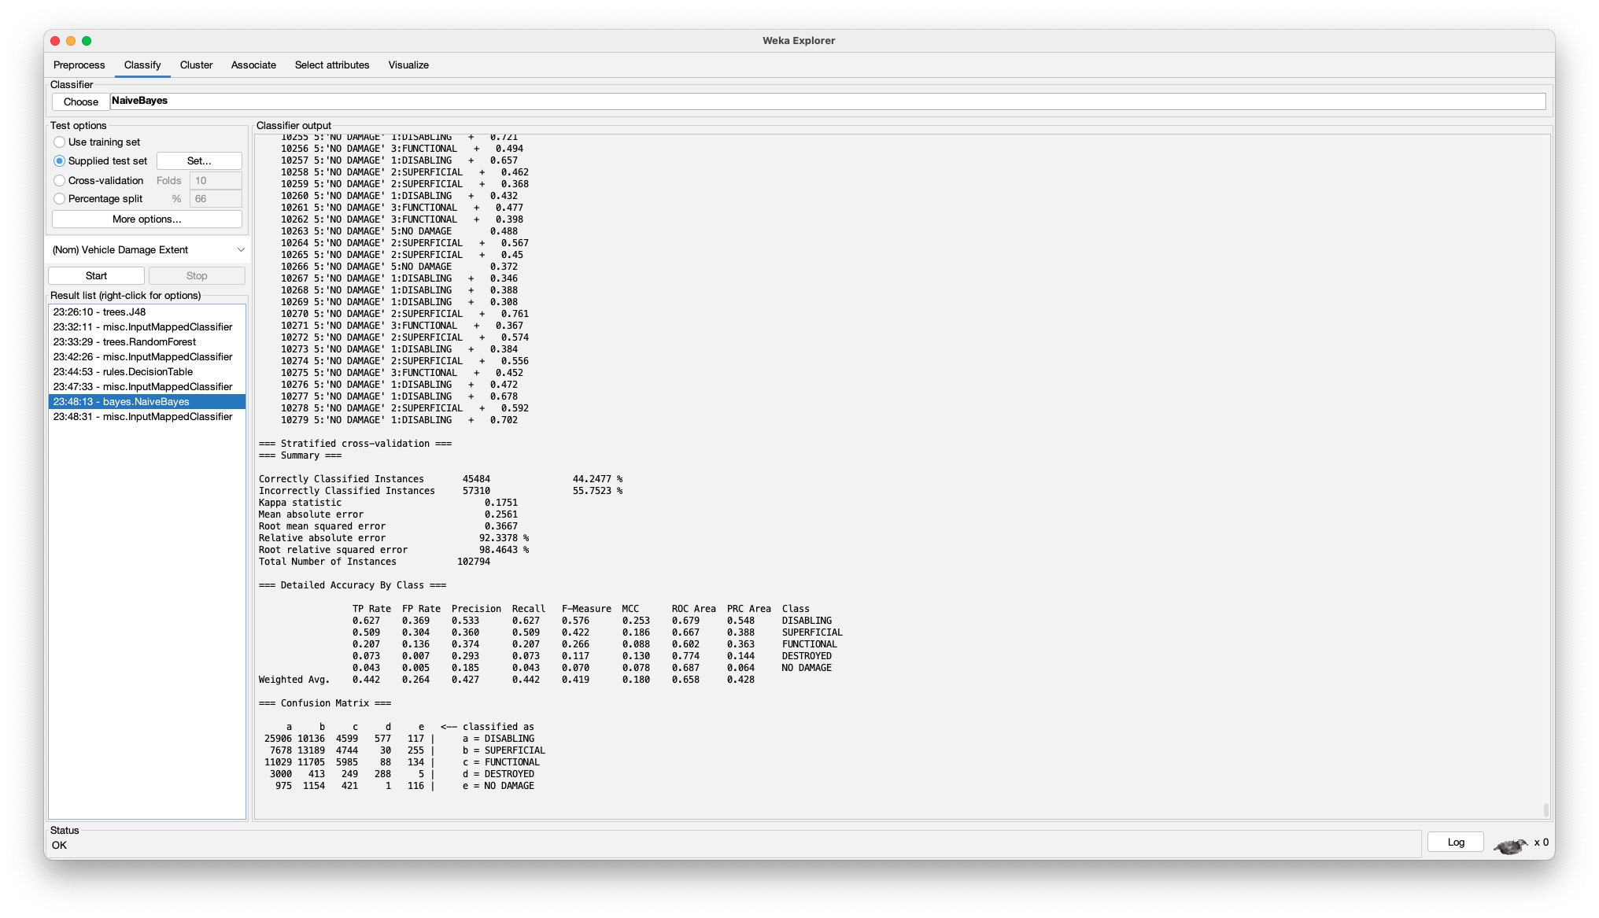

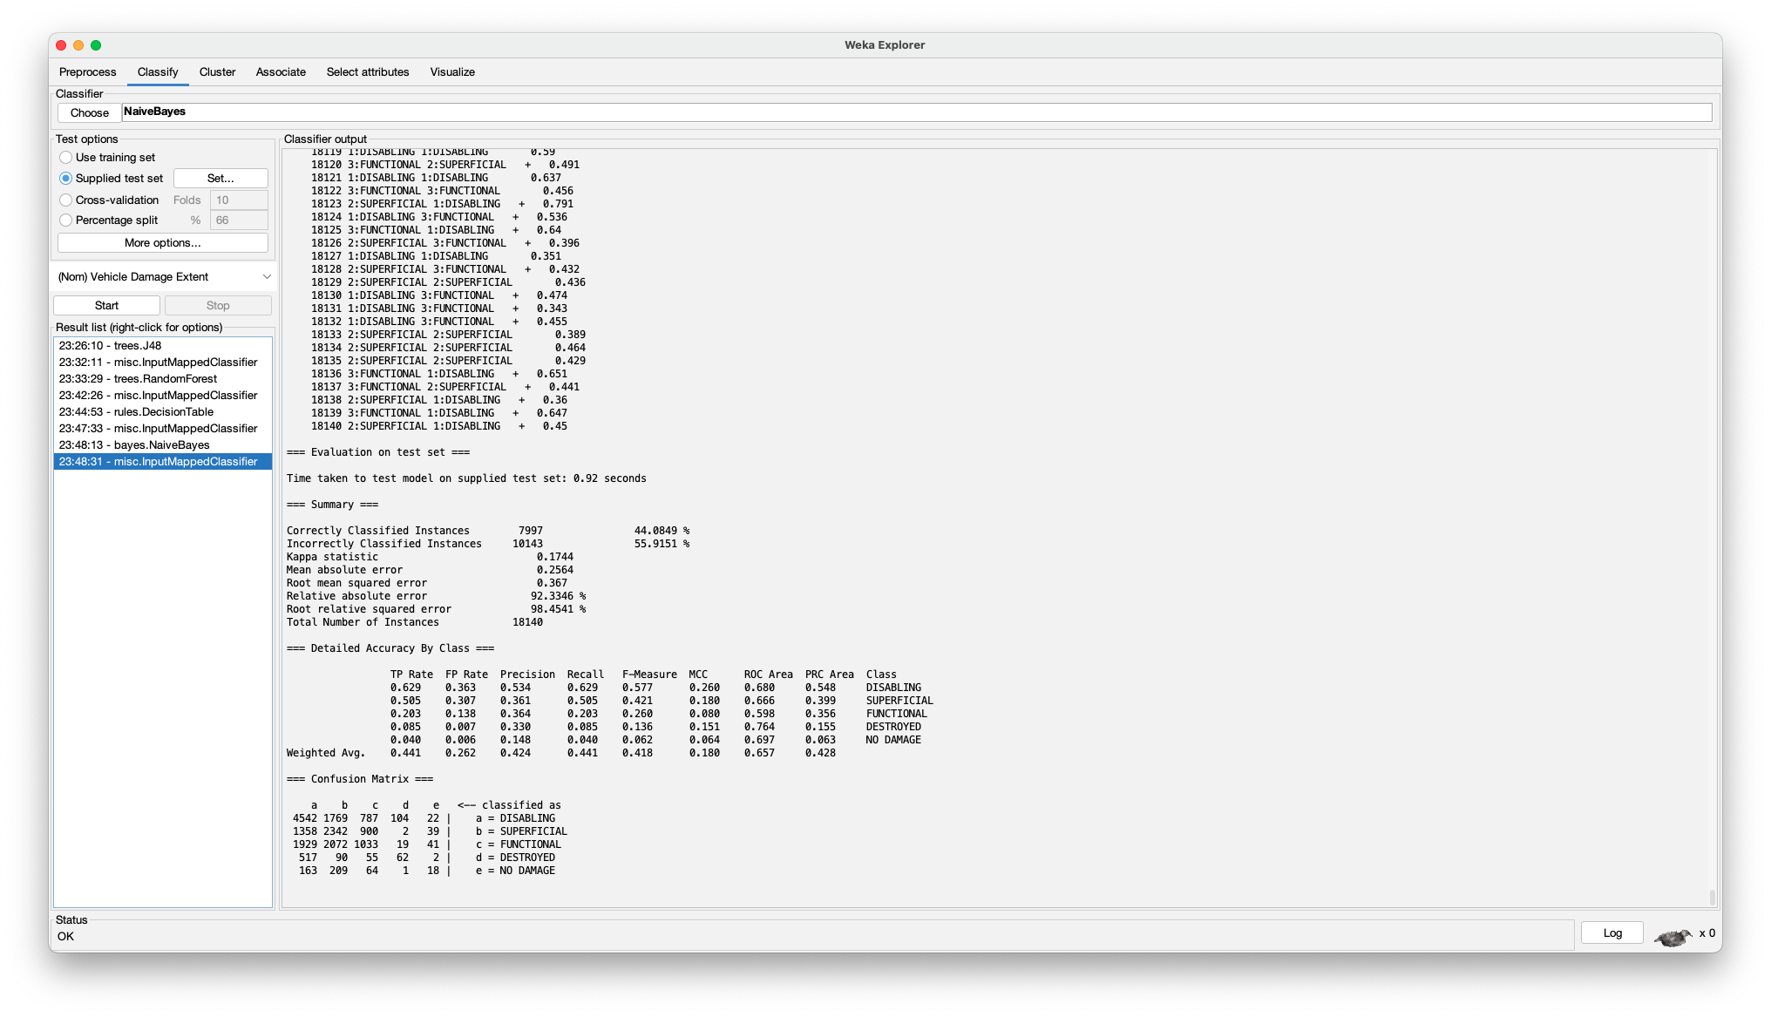

1. **Correlation-based Feature Selection:**

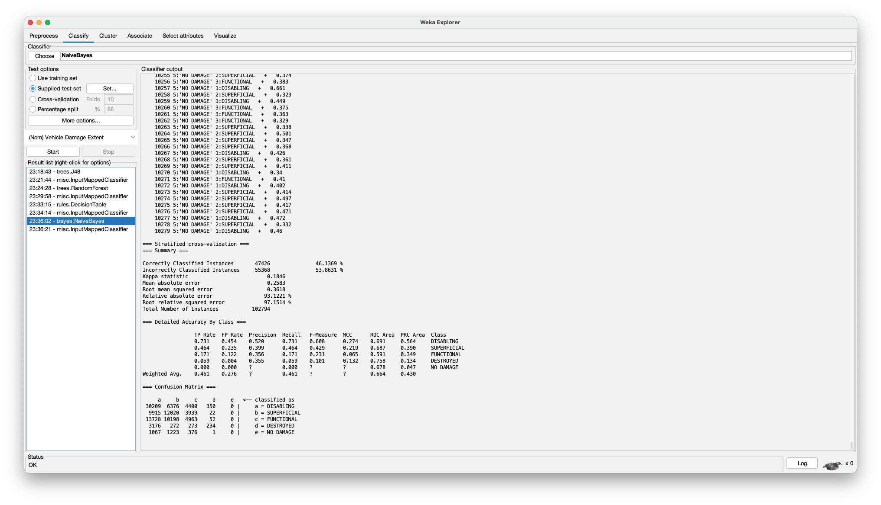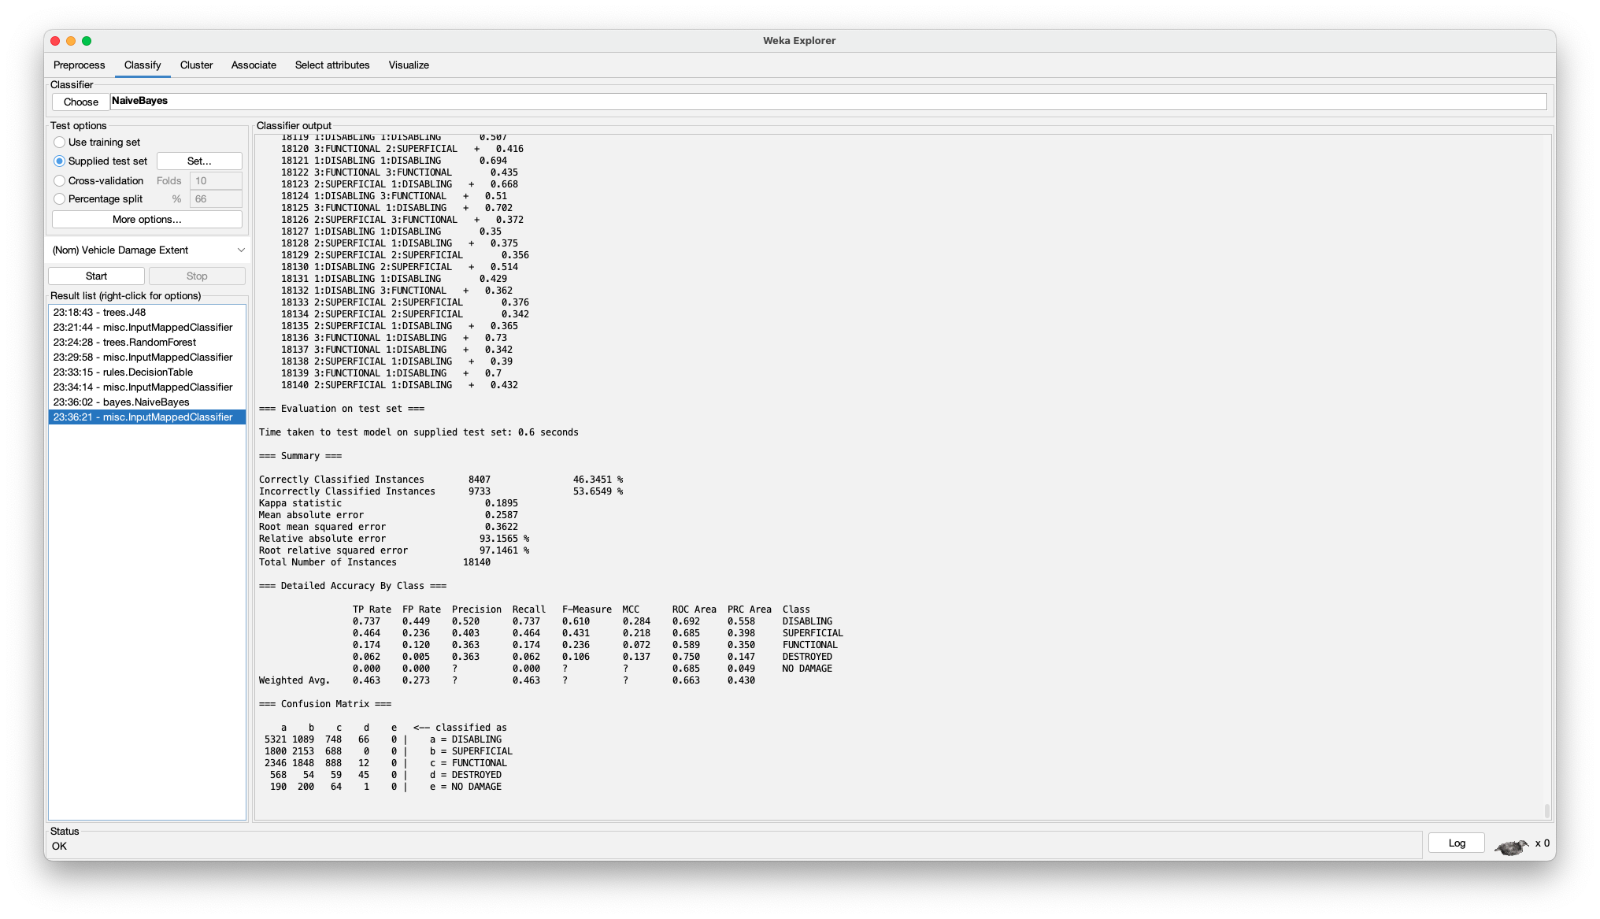

1. **Random Forest:**

A model that creates multiple decision trees and combines their results to make the most accurate model. It is good at handling all data types and it effectively works with high-dimension data like our dataset.

1. **Non-Weka:**

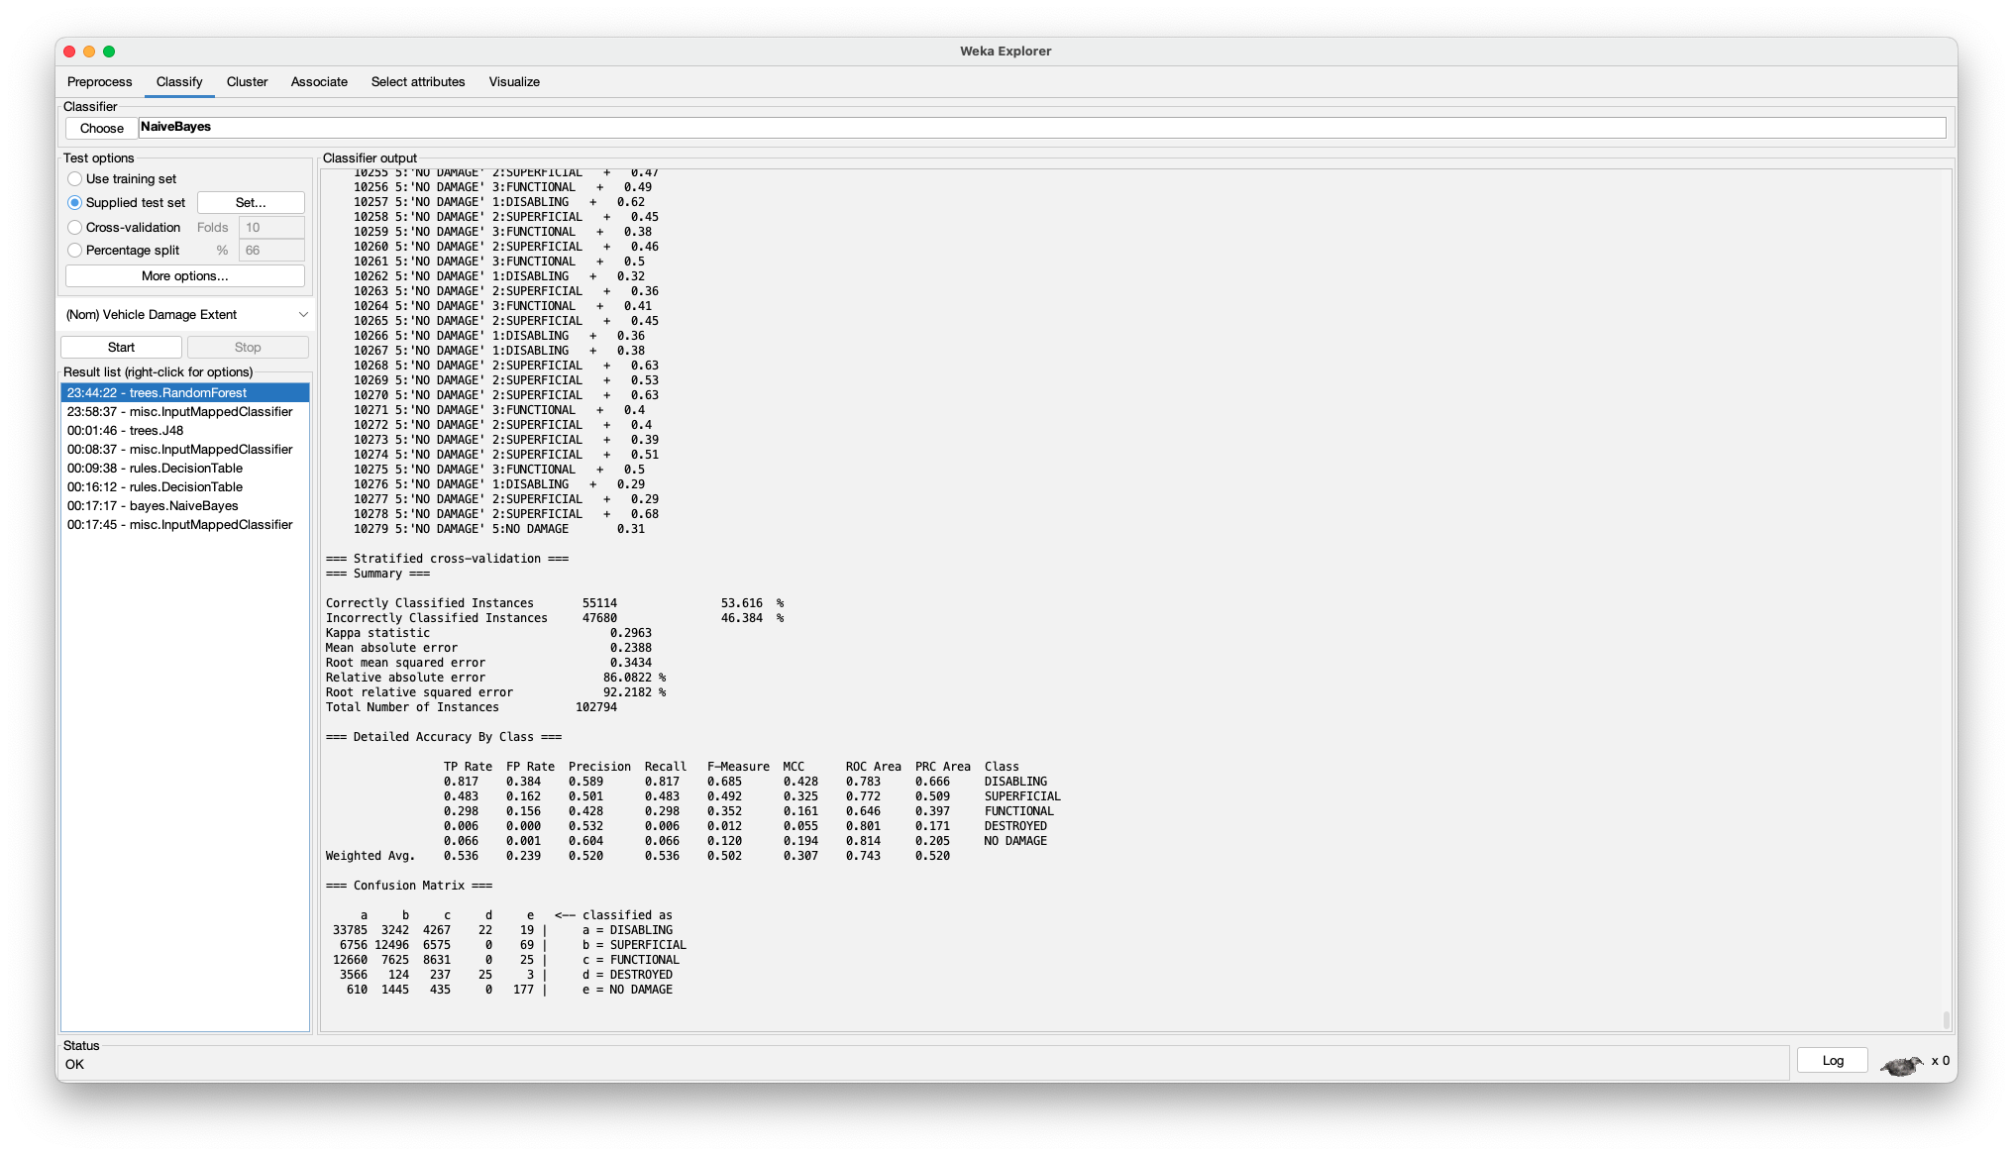

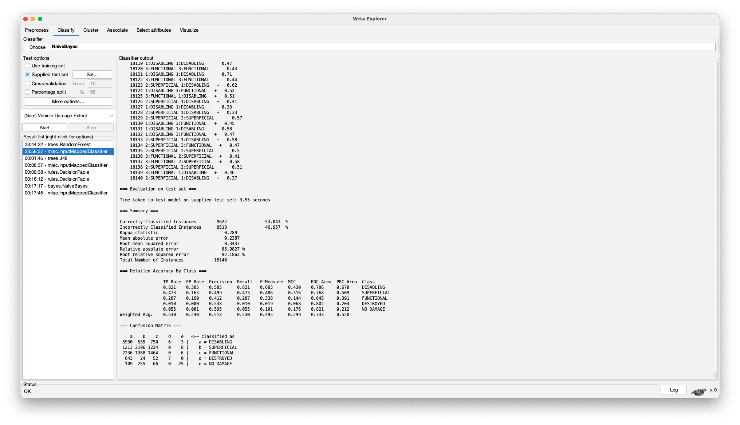

1. **Information Gain:**

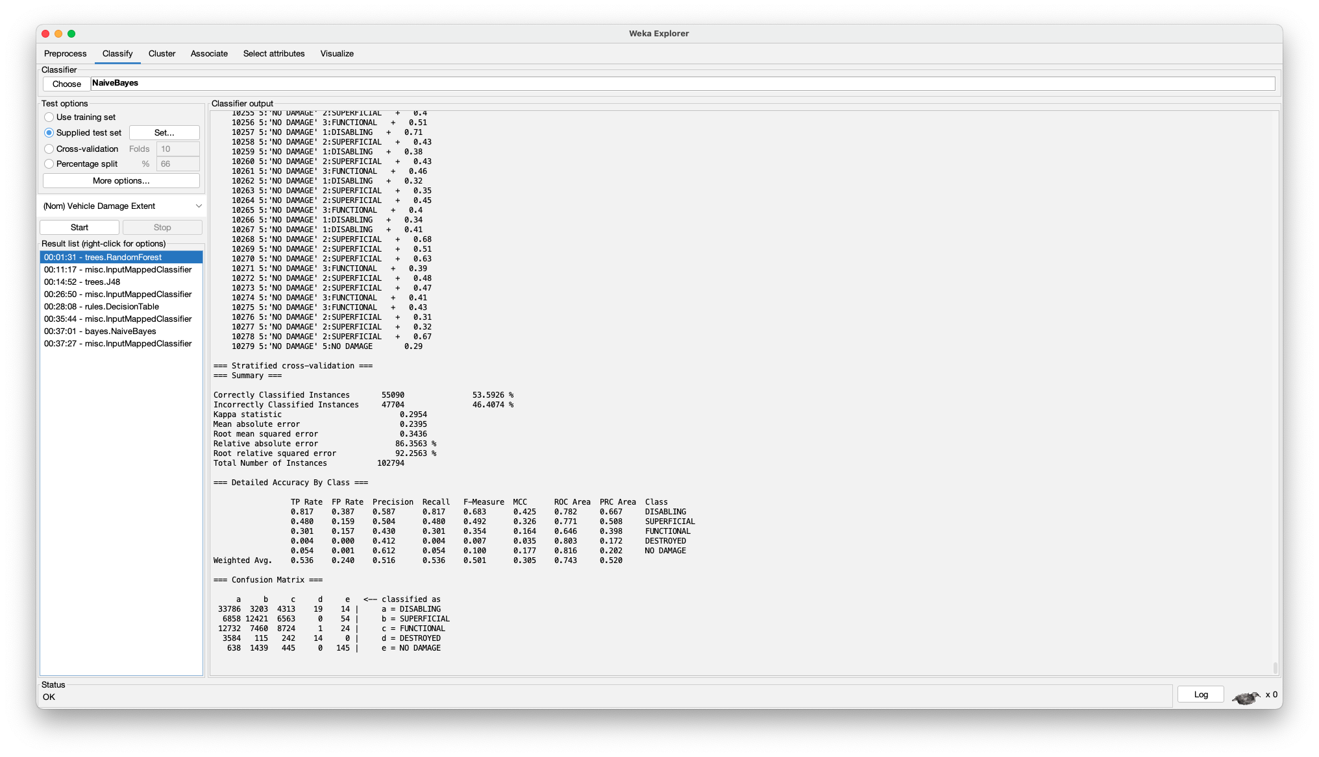

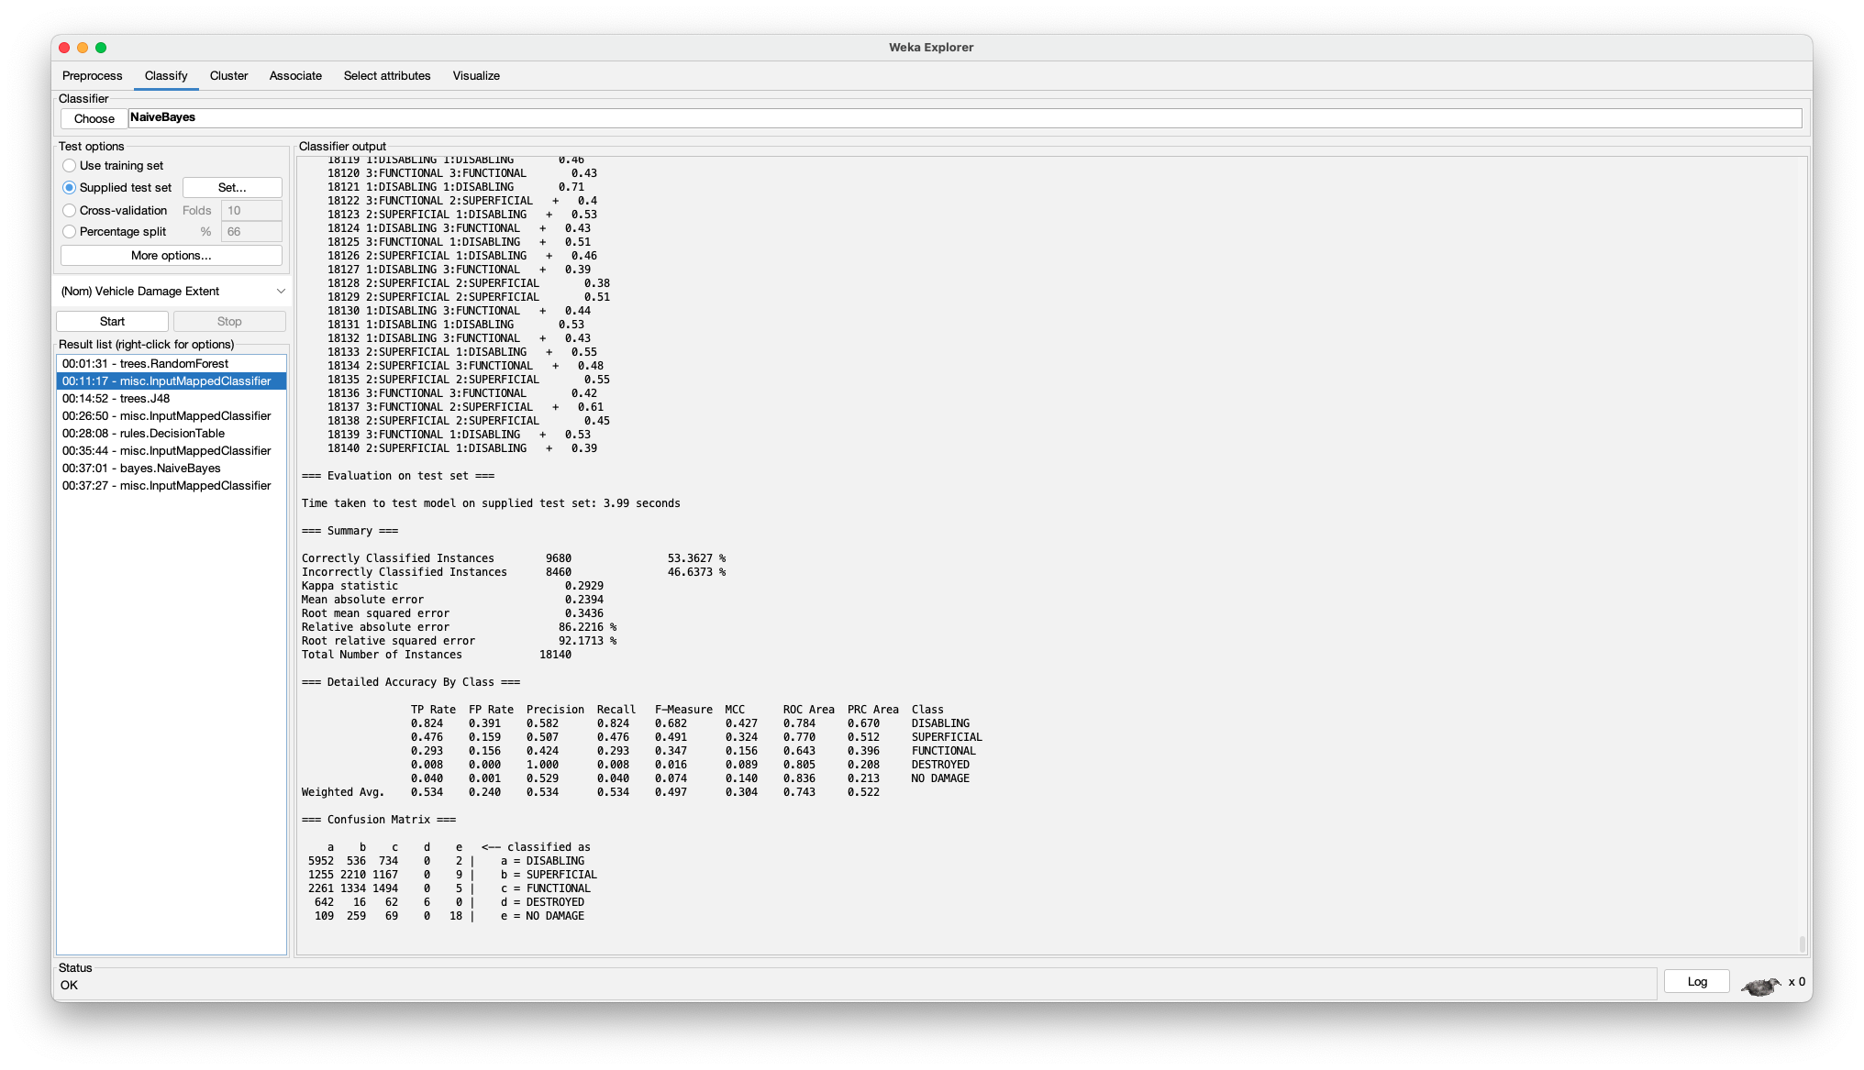

1. **Gain Ratio:**

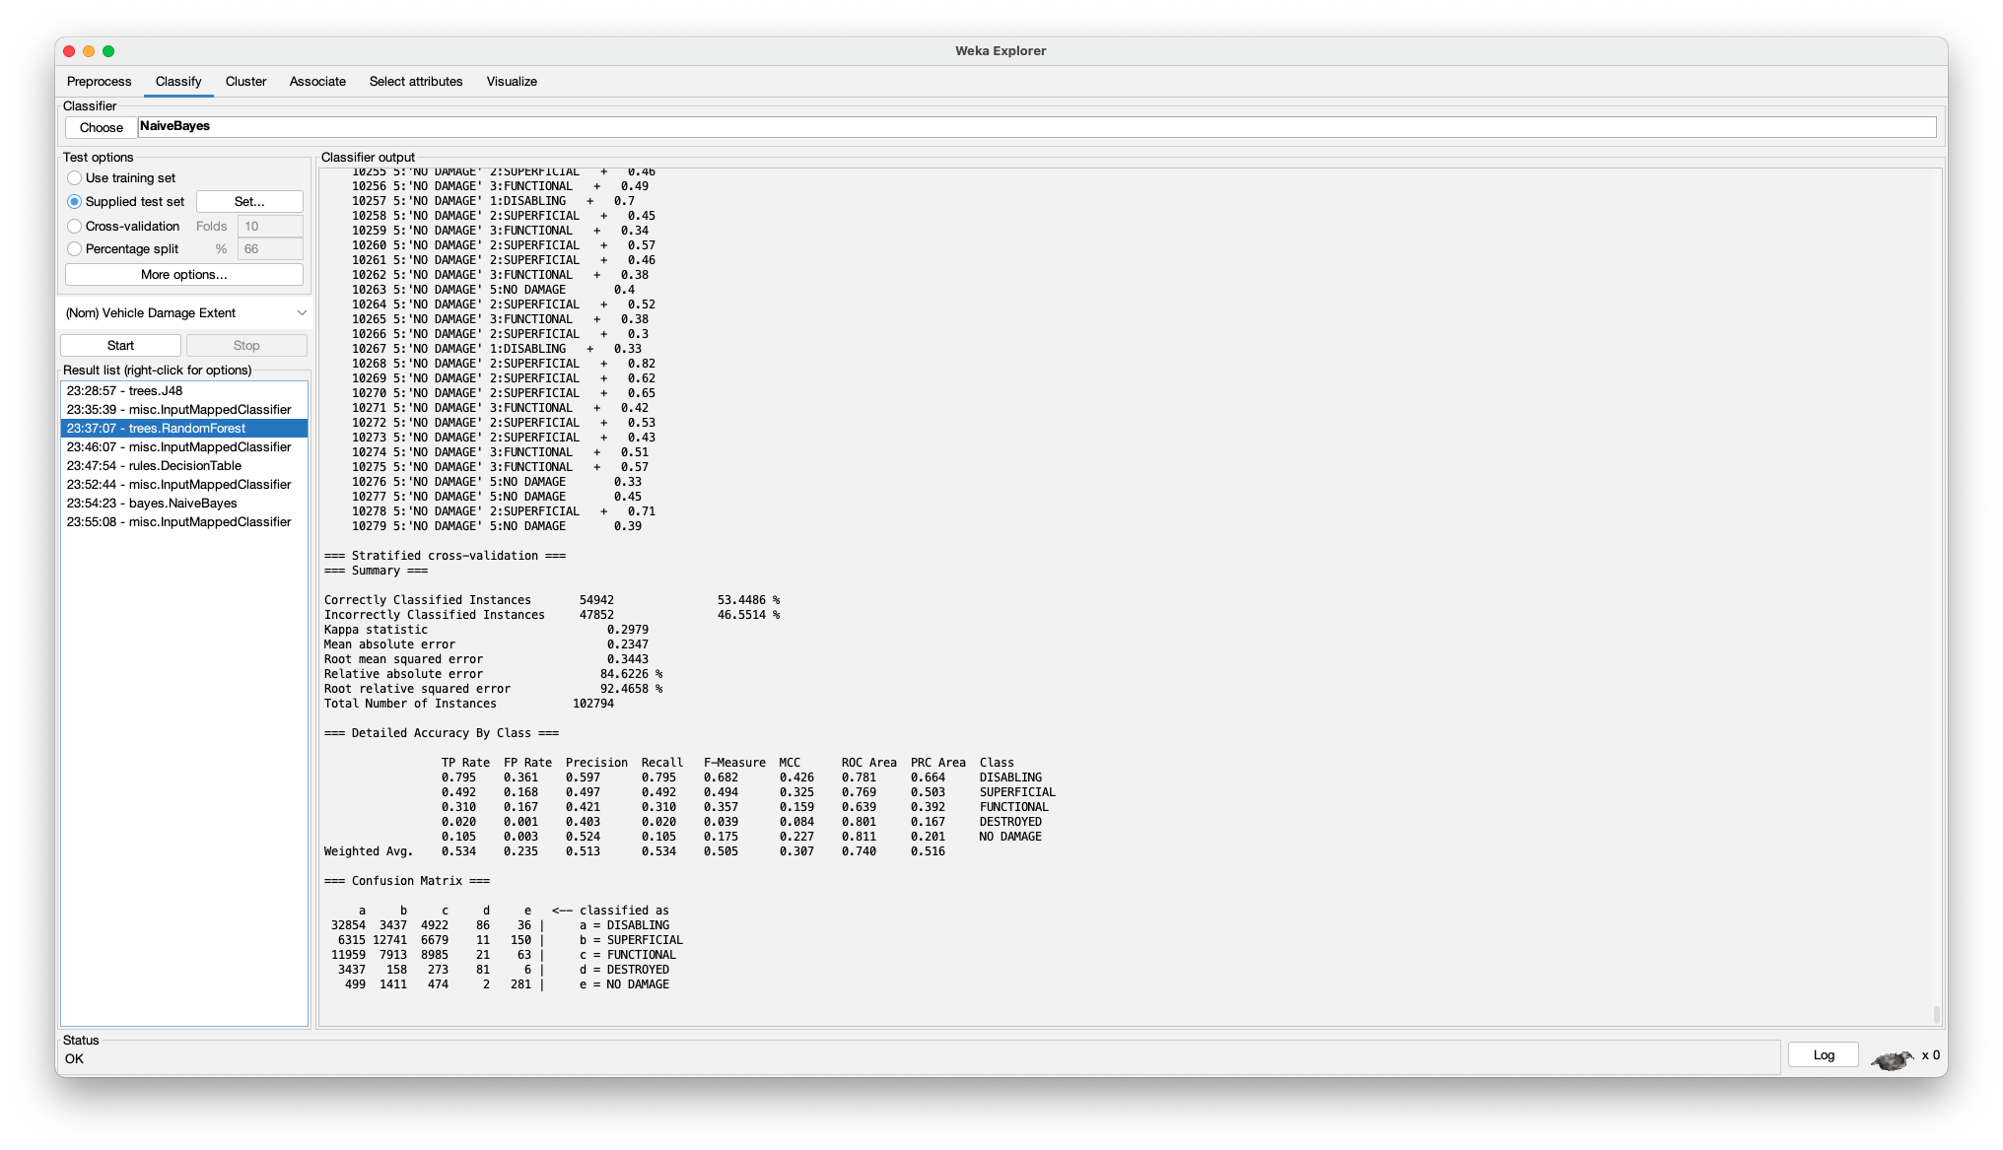

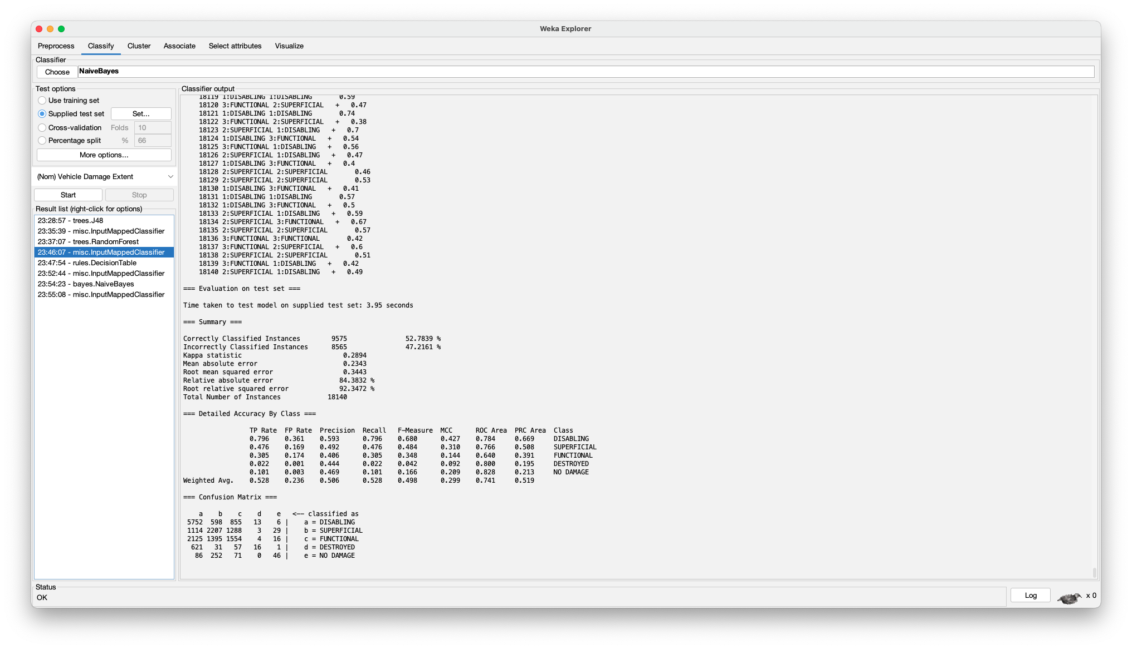

1. **Correlation:**

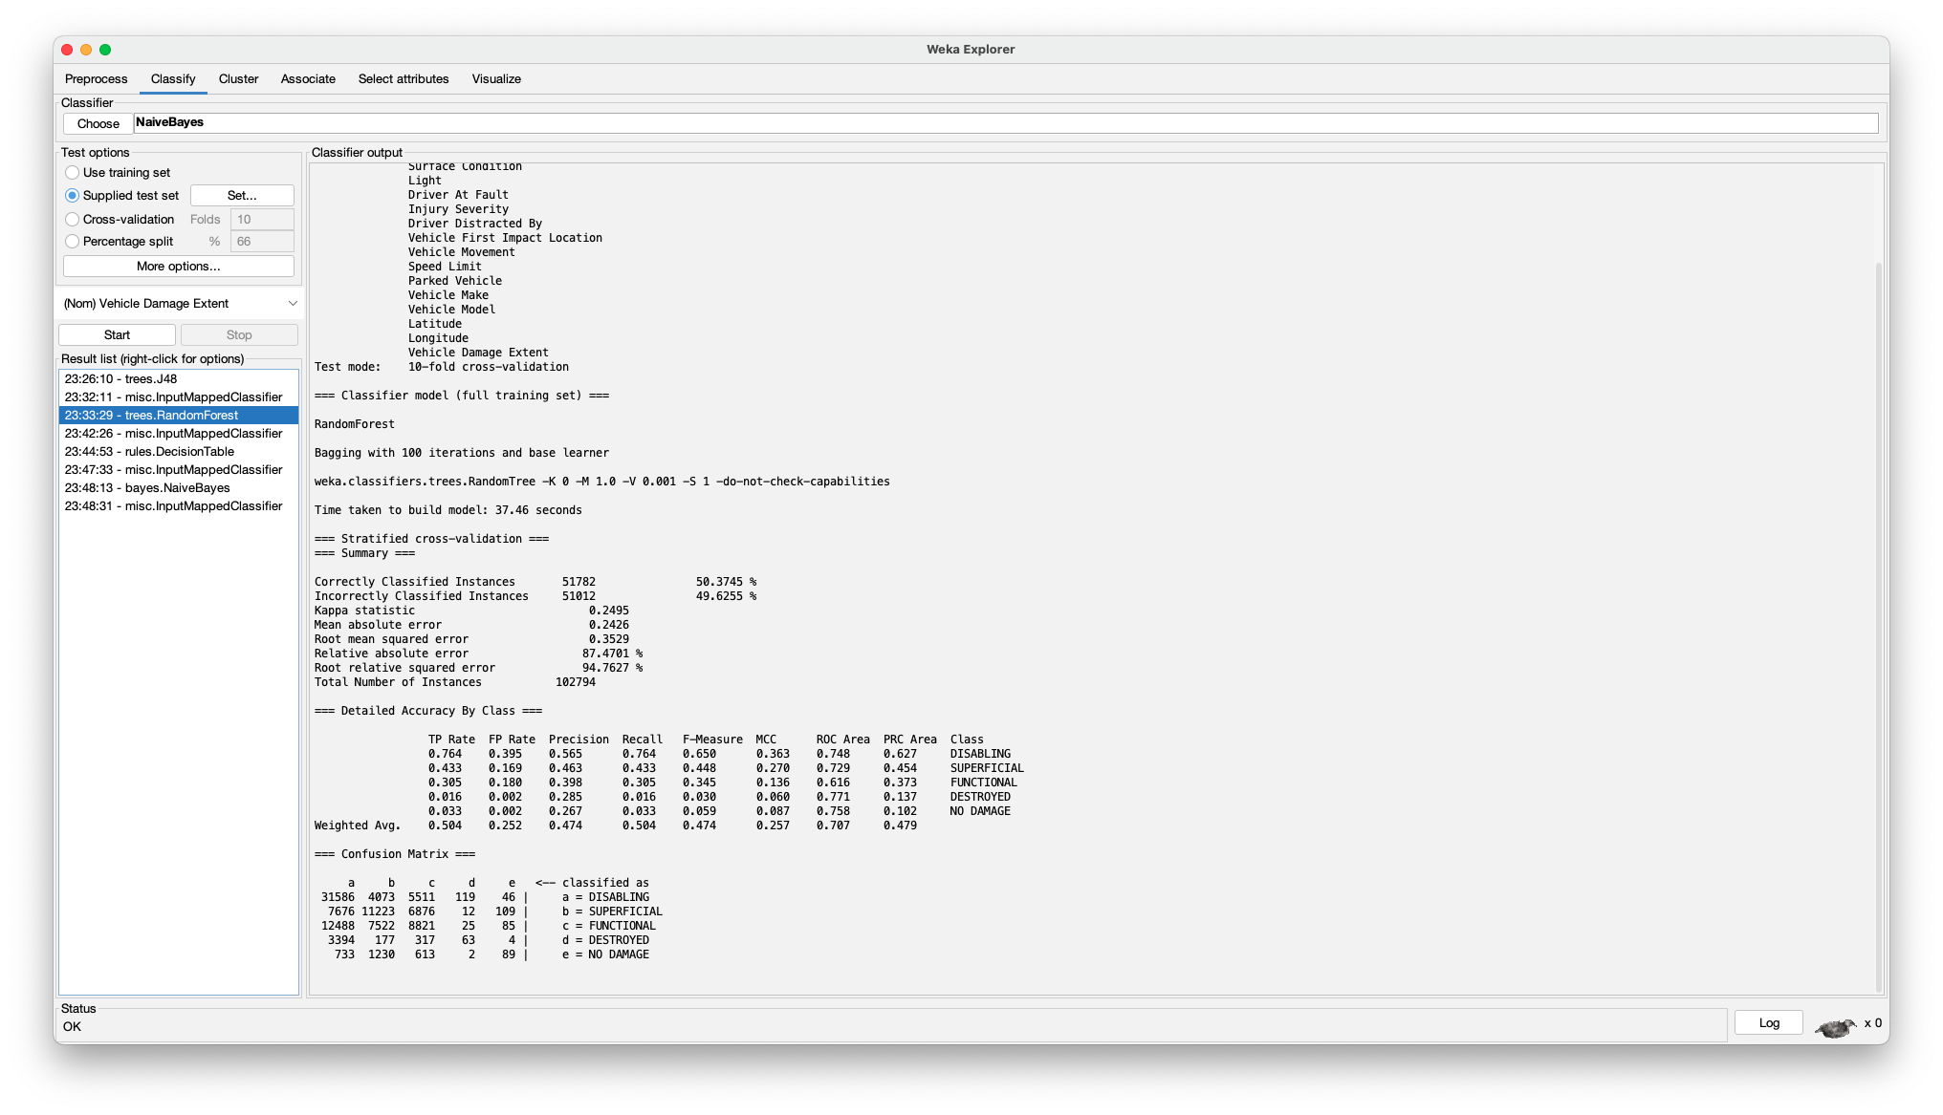

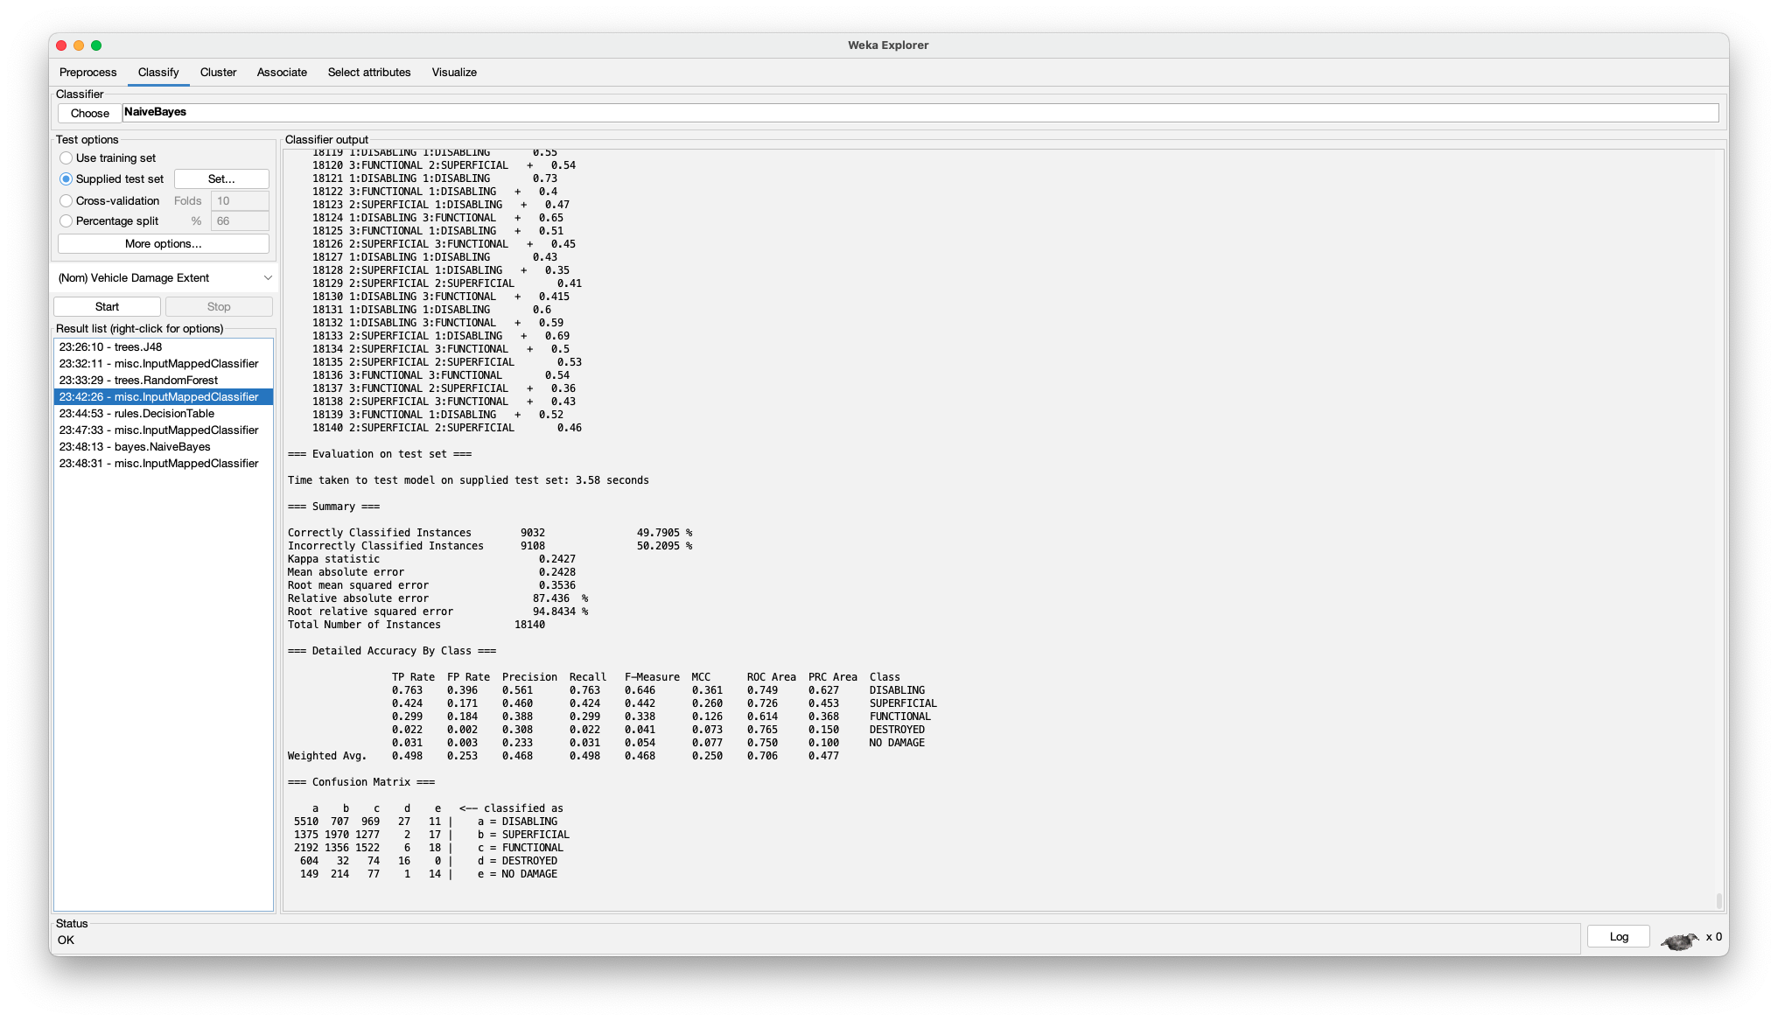

1. **Correlation-based Feature Selection:**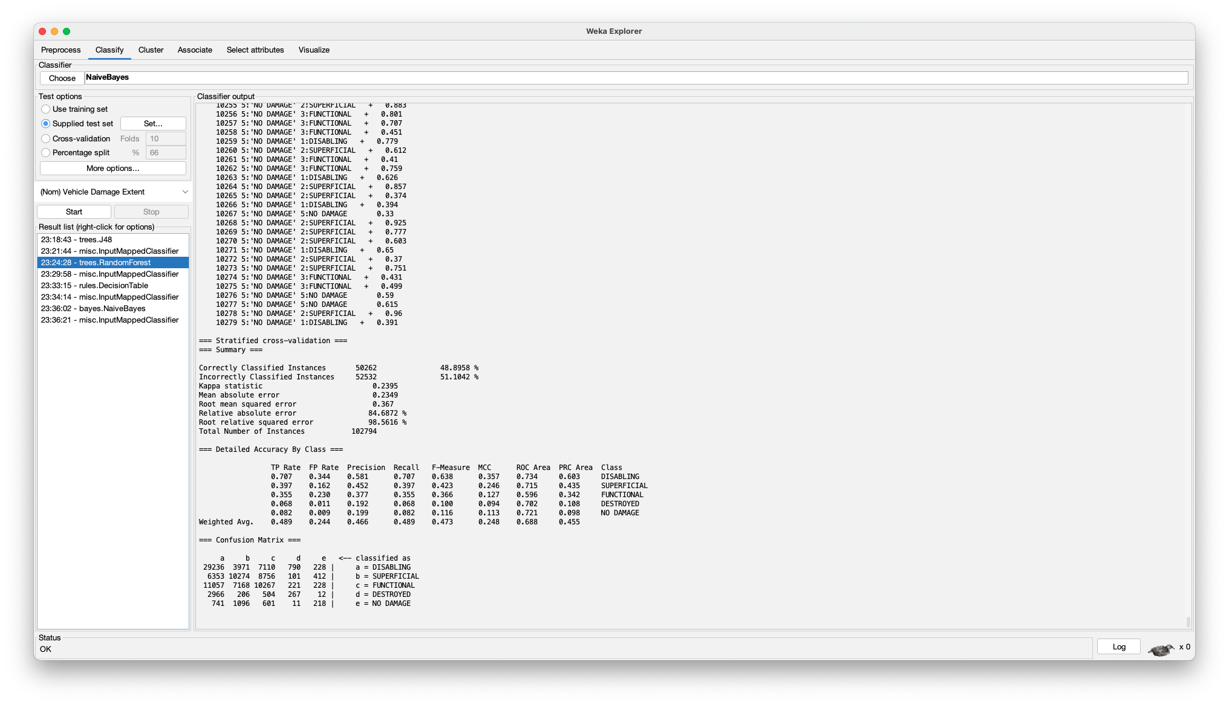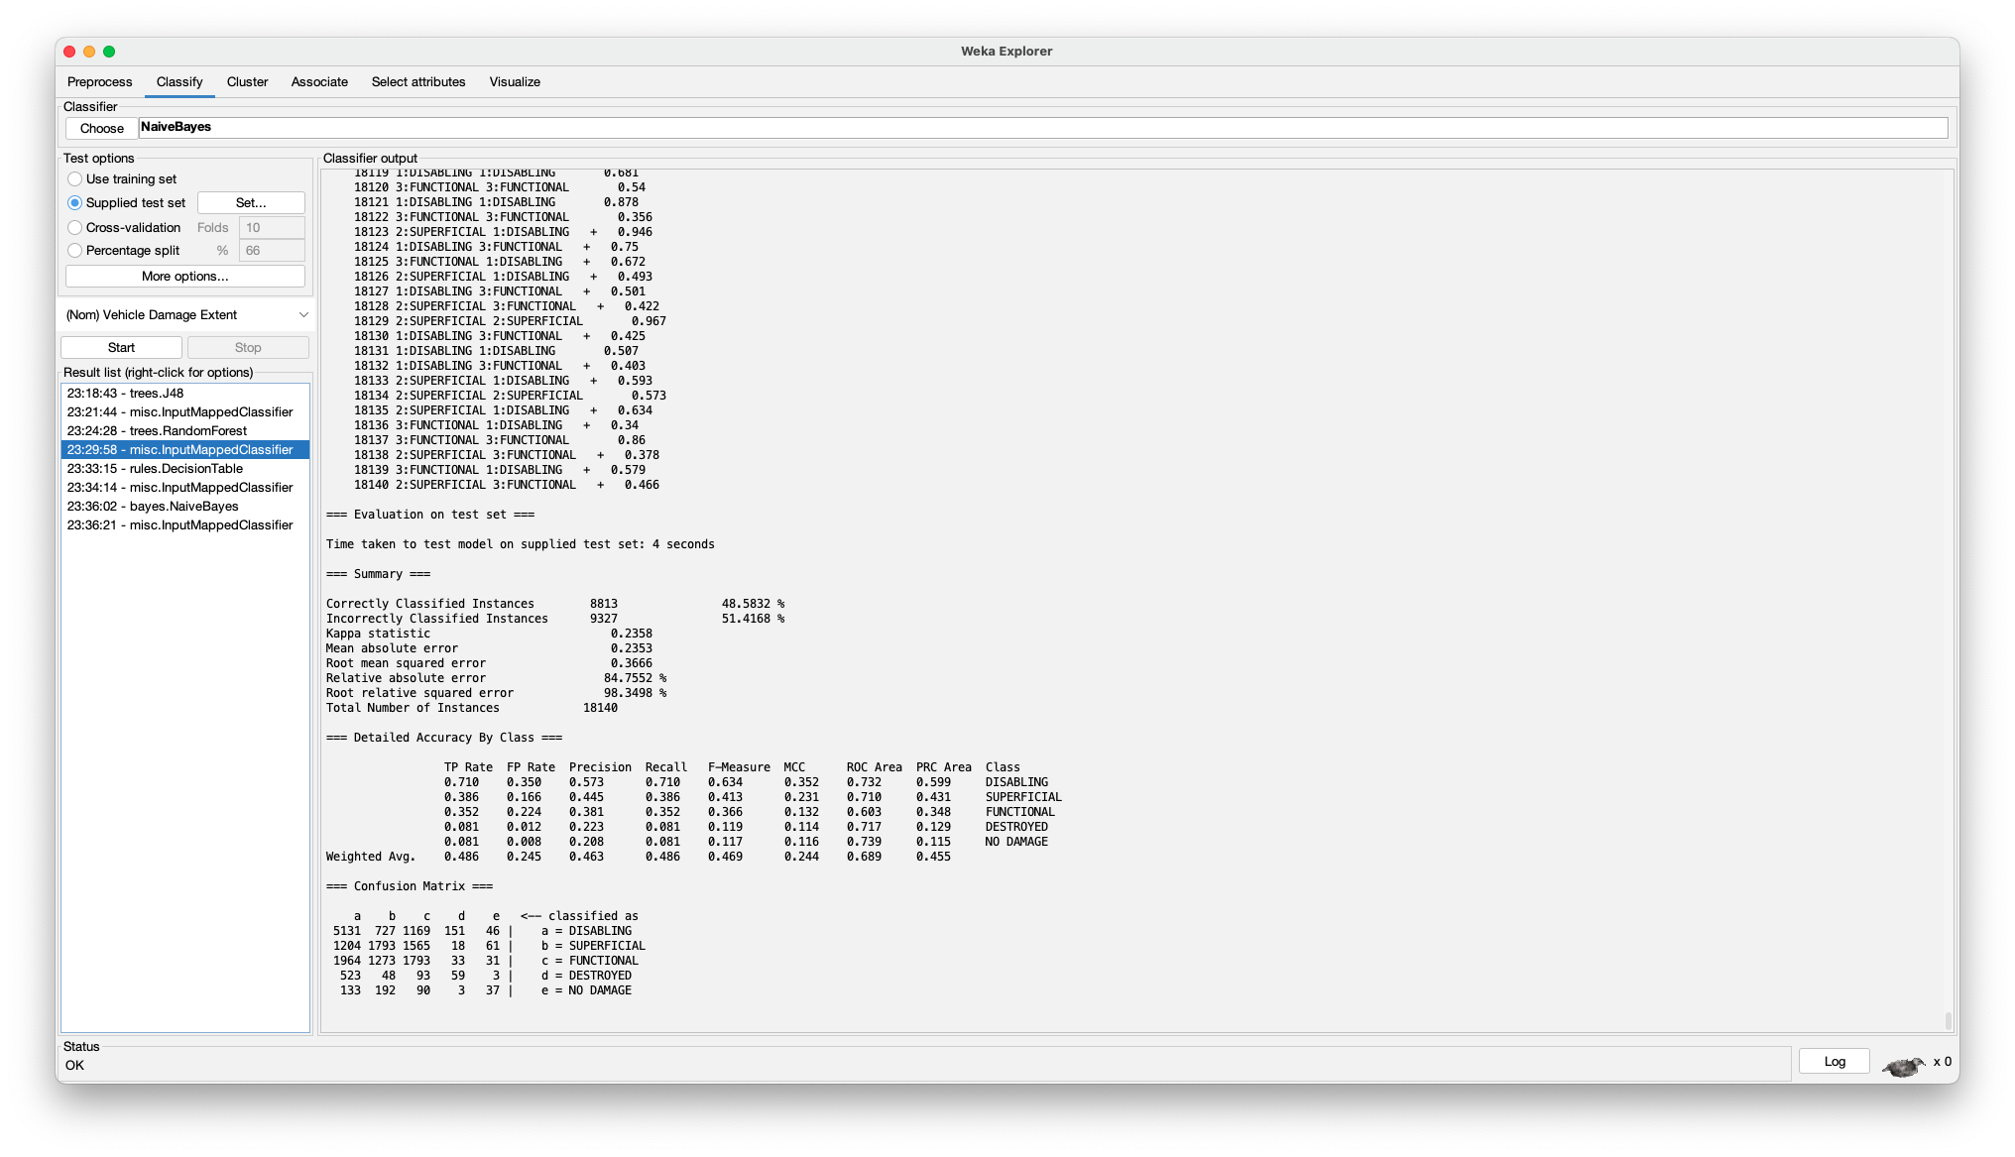

**Table 3**

*K-fold accuracy*

|  | **Non-Weka** | **InfoGain** | **GainRatio** | **Correlation** | **CFS** |
| --- | --- | --- | --- | --- | --- |
| **J48** | 44.9063% | 44.4403% | 47.2168% | 45.7673% | 46.3451% |
| **Decision Table** | 51.8493% | 51.8493% | 51.8493% | 50.2315% | 51.6947% |
| **Naive-Bayes** | 43.4918% | 43.4792% | 44.417% | 44.2477% | 46.1369% |
| **Random Forest** | 53.616% | 53.5926% | 53.4486% | 50.3745% | 48.8958% |

*Note.* K-fold accuracies per model and attribute selection algorithm

**Table 4**

*Test accuracy*

|  | **Non-Weka** | **InfoGain** | **GainRatio** | **Correlation** | **CFS** |
| --- | --- | --- | --- | --- | --- |
| **J48** | 44.9835% | 44.3495% | 47.6185% | 46.097% | 46.1369% |
| **Decision Table** | 53.9083% | 51.6979% | 51.6979% | 49.581% | 51.2348% |
| **Naive-Bayes** | 43.5226% | 43.5722% | 44.548% | 44.0849% | 46.3451% |
| **Random Forest** | 53.043% | 53.3627% | 52.7839% | 49.7905% | 48.5832% |

*Note.* Test accuracies per model and attribute selection algorithm

**Part 6: Conclusion and Tasks Performed**

In this project, we developed 20 models to predict the extent of vehicle damage from the Automated Crash Reporting System dataset. The accuracies were suboptimal (all ~50%), with Non-weka Random Forest being the highest with 53.616% accuracy, but that was due to our class attribute’s inherent variability. The make and model of a car significantly impacts the damage it receives, and our dataset did not have enough data on every make and model to create a proper relationship between that and vehicle damage. In conjunction with this, the slightest changes in angles and speed have a drastic effect on the damage a vehicle takes, and on top of this, the vehicle damage is partly subjective; for example, there is a fine line between functioning and superficial damage, and there is no objective scale for measuring vehicle damage. With our skewed dataset, there was bias towards the more present labels like “disabling.” This is evident when looking at the True Positive (TP) rates of all our models; the TP rate of disabling (~0.7) is significantly higher than the TP rate of every other label.

In terms of tasks performed, Aniketh Luchmapurkar worked on creating the code (python scripts), running most of the Weka processes, and wrote a bit of the report; Ryan Ghimire also worked on some of the Weka processes and wrote the majority of the report as well as the presentation.

**Part 7: Reproducibility of Best Model**

1. Data setup
   1. Download the trainMerged_ND.csv under ML Q1 Project > Cleaned and Split Data > nonweka

**OR**

* 1. Manual data setup
     1. Download data from: <https://catalog.data.gov/dataset/crash-reporting-drivers-data>
     2. Run cleaner.py under “ML Q1 Project” Google Drive folder
     3. Run base_preprocessing.py under “ML Q1 Project” Google Drive folder
     4. Run encoder.py under “ML Q1 Project” Google Drive folder
     5. Open csv outputted by previous step in Weka. Perform a train-test-validation split using stratified random sampling in Weka.
        1. Under Filter, press Choose and go to weka > filters > supervised > instance > Resample



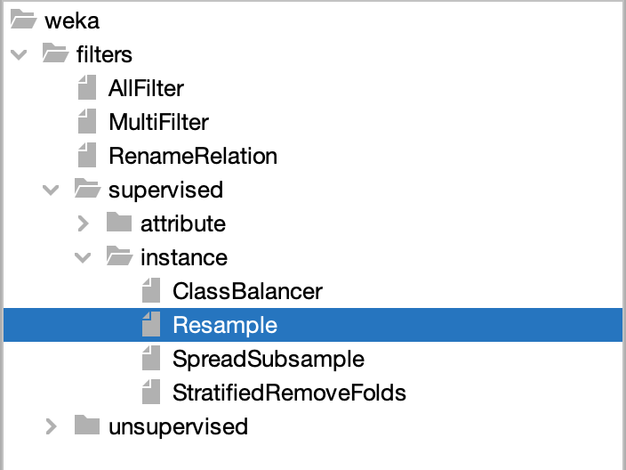

* + - 1. Then, click on the box to the right of the Choose button (the box should say Resample if you chose the correct filter) to open the weka.gui.GenericObjectEditor where you can then edit the parameter of the Resample filter.



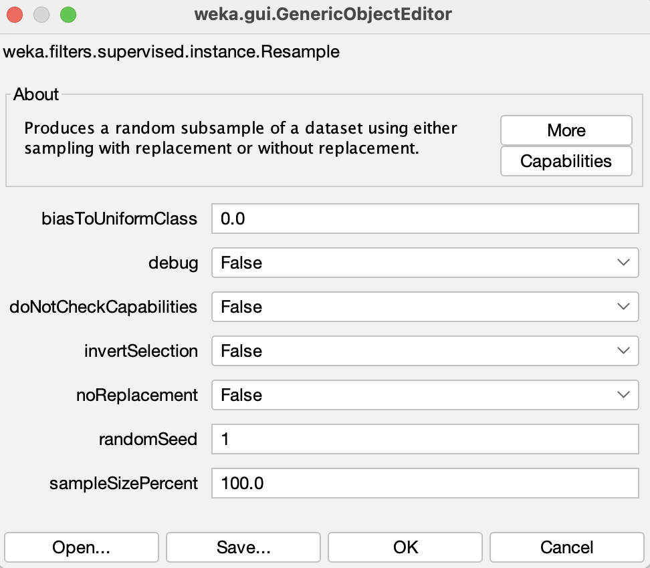

* + - 1. Then, set the noReplacement parameter to True, so each instance is only selected once. Set the sampleSizePercent to the proportion of the dataset to be in your training dataset (in our case, we are doing a 70/15/15 split so the training set has 70% of the data).



* + - 1. Press Ok and then Apply to run the filter. Congratulations, you have your training set. Now press Save… to save the newly made subset. Now, you have to run another Resample filter to get your testing and validation sets. Reopen your original dataset, and repeat the prior steps until you are on the screen where you edited all the parameters for the Resample filter. Use the exact same parameters as before, but now, this time set invertSelection to True. This will give you the other 30% of the dataset, which you will now split into your test and validation sets.

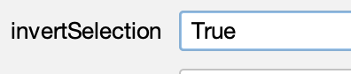

* + - 1. Repeat the same steps as before on this dataset, but now set your sampleSizePercent accordingly to how you want to split your dataset (We are making the test and validation sets both 15% of the dataset, so we will set our sampleSizePercent to 50.0 since we are working with 30% of the data right now). Run the filter and save your test set, then repeat that again, but setting invertSelection to True this time to get your validation set.

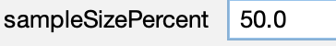

* + 1. Perform attribute selection algorithms as detailed in Part 4. As each arff file is being produced, place said file in a folder with its respective name (correlation, GainRatio, InfoGain, nonweka, CFS)
    2. Run merge.py to combine the training and validation sets
    3. Run fixNoDamage.py to clean up the class labels (this is to get rid of stray quotations added by Weka)

1. Open Weka and load the file trainMerged_ND.csv
   1. If this was downloaded from Google Drive, it should be in home directory
   2. If this was created from scratch, it should be under the “nonweka” folder
2. Navigate to the classify tab choose the RandomForest classifier under weka > classifiers > trees
3. Press start and view the results in the classifier output window

**References**

* dataMontgomery. (2024). Crash Reporting - Drivers Data. <https://catalog.data.gov/dataset/crash-reporting-drivers-data>
* Class Slides